# Supplementary Information for

The Value of Car Ownership and Use in the United States

# Data Collection

## Case Study City Selection

For this study, we selected four U.S. metropolitan areas that represented a diversity of geographic region within the U.S. and level of “car dependence” measured in terms of household car ownership and commuter car use and traffic (INRIX, 2018). Due to the variation in governance, culture, and urban form found in different geographic regions, we selected one city each from the East Coast (Washington, D.C.), West Coast (Seattle, WA), South (Dallas, TX), and the Interior (Chicago, IL). In terms of car dependence, Dallas, TX has the highest average number of cars and lowest percentage of zero-car households of any of the cities select, with these numbers also being above and below the U.S. national average, respectively (see Table 1). On the other hand, Chicago, IL has the lowest average number of cars per household and the highest percent of households that do not own a car among the cities selected.

Because our study considered ridehailing as an alternative to private car ownership and use, we wanted to ensure that respondents in each of our target metropolitan areas was likely to be familiar with such services. Therefore, all four of our selected cities are among the top or middle tier of cities in terms of number of ridehailing trips (Table 1).

Table 1. Characteristics of case study metropolitan areas

|  |  |  |  |  |
| --- | --- | --- | --- | --- |
|  | Chicago, IL | Dallas, TX | Seattle, WA | Washington, D.C. |
| Household car ownership:  Average # cars per household  Zero-car households (%) | 2.08  6.14 | 2.29  1.71 | 2.25  3.69 | 2.17  5.45 |
| Commute mode share:  Drive alone (%)  Carpool (%) | 70.0  7.62 | 80.9  9.61 | 67.6  10.5 | 66.4  9.18 |
| Traffic rank (2018) | 3 | 21 | 6 | 2 |
| City rank in terms of number of ridehailing trips | Top 8 | Top 8 | Mid 11 | Top 8 |
| Previous research on ridehailing | Shabanpour, Golshani, & Mohammadian, 2018 | Lavieri & Bhat, 2019 | Dias, et al., 2017 |  |

*Sources:* Household car ownership and commute mode share data from American Community Survey (2017a); traffic rank from INRIX (2018); rank in terms of number of ridehailing trips from Schaller (2018) based on data from the U.S. National Household Travel Survey (2017).

## Sample

Respondents for our online survey were recruited by a professional panel company, Qualtrics. Quota sampling was used to ensure statistical representativeness of each metropolitan area sample by age, household income, and household car ownership. However, there was difficulty in reaching respondents in the lowest income bracket and those whose household owned three or more cars; therefore, these quotas were relaxed towards the end of data collection. We collected a total of 4,937 responses from which 915 individuals were screened out by quota questions, failed quality checks embedded in the survey, or failed to complete all sections of the survey. This left us with a final sample size of 4,022 responses, with 1,017 from Washington, D.C., 1,006 from Chicago, 1,001 from Seattle, and 998 from Dallas.

Table 2. Sociodemographic breakdown of our sample (S) compared to the population (P) for each city

|  |  |  |  |  |  |  |  |  |  |
| --- | --- | --- | --- | --- | --- | --- | --- | --- | --- |
|  | | Washington, D.C. | | Chicago, IL | | Dallas, TX | | Seattle, WA | |
| P | S | P | S | P | S | P | S |
| Gender | Male | 48.9 | 42.0 | 48.9 | 36.7 | 49.2 | 38.2 | 50.0 | 42.4 |
| Age | 18-29 | 21.3 | 23.3 | 21.8 | 21.1 | 22.5 | 22.0 | 21.5 | 19.0 |
| 30-39 | 19.8 | 19.9 | 18.3 | 18.7 | 19.8 | 20.1 | 19.8 | 21.8 |
| 40-49 | 18.5 | 20.4 | 17.5 | 18.3 | 19.1 | 18.8 | 17.7 | 17.4 |
| 50-59 | 17.8 | 17.2 | 17.7 | 18.4 | 17.5 | 18.1 | 17.4 | 17.4 |
| 60+ | 22.6 | 21.2 | 24.7 | 23.6 | 21.1 | 21.0 | 23.6 | 24.5 |
| Annual household income | Less than $25K | 10.8 | 9.5 | 19.0 | 13.1 | 17.2 | 14.5 | 14.2 | 11.4 |
| $25K - $50K | 13.3 | 12.2 | 19.9 | 16.1 | 21.8 | 18.1 | 17.6 | 15.8 |
| $50K - $75K | 14.6 | 14.2 | 16.8 | 17.6 | 18.2 | 18.9 | 16.8 | 17.4 |
| $75K - $100K | 12.7 | 13.8 | 12.8 | 14.9 | 12.6 | 14.1 | 13.6 | 14.6 |
| $100K - $150K | 20.2 | 21.8 | 16.0 | 18.7 | 15.6 | 18.1 | 18.4 | 20.5 |
| $150K - $200K | 12.0 | 13.6 | 7.4 | 9.7 | 7.0 | 7.9 | 9.0 | 10.1 |
| $200K or more | 16.4 | 14.8 | 8.2 | 9.8 | 7.6 | 8.2 | 10.3 | 10.3 |
| Household car ownership | 0 | 5.6 | 7.2 | 6.3 | 7.3 | 1.9 | 2.9 | 3.9 | 6.0 |
| 1 | 23.0 | 35.4 | 24.4 | 26.7 | 20.3 | 25.2 | 21.5 | 31.0 |
| 2 | 39.1 | 39.7 | 40.6 | 43.5 | 44.5 | 48.4 | 40.9 | 42.8 |
| 3 or more | 32.2 | 17.7 | 28.7 | 22.5 | 33.3 | 23.4 | 33.7 | 20.3 |
| Household size | 1 | 27.0 | 14.6 | 28.7 | 14.4 | 24.8 | 12.4 | 27.8 | 17.2 |
| 2 | 30.6 | 26.4 | 30.4 | 32.5 | 30.9 | 33.1 | 34.2 | 33.8 |
| 3 | 16.8 | 23.6 | 15.7 | 18.2 | 16.8 | 19.3 | 15.9 | 21.0 |
| 4 or more | 25.7 | 23.9 | 25.1 | 22.9 | 27.5 | 20.4 | 22.1 | 16.8 |
| Education level | High school diploma or less | 29.2 | 13.0 | 37.0 | 17.6 | 38.8 | 17.0 | 29.4 | 12.4 |
| Assoc. degree or some college | 24.6 | 25.2 | 29.0 | 26.0 | 30.4 | 29.7 | 32.3 | 31.1 |
| College degree | 24.5 | 27.9 | 21.3 | 33.7 | 20.6 | 33.9 | 24.6 | 35.7 |
| Advanced degree | 21.8 | 33.9 | 12.7 | 22.7 | 10.2 | 19.5 | 13.7 | 20.9 |
| Unemployed (%) | | 8.4  (3.1) | 11.0 | 16.3  (3.6) | 14.9 | 8.2 (3.3) | 16.3 | 10.0 (3.3) | 14.8 |

*Sources:* Age, income, household car ownership, household size, and education level from the American Community Survey (2017b-g); unemployment data for June 2020 (and 2019 annual average) are from U.S. Bureau of Labor Statistics (2020).

Table 2 includes details on the representativeness of each of our metropolitan area samples. Across our cities, we find that we are overrepresenting individuals with high educational attainment (advanced degrees) compared to those who attained no more than a high school diploma. Households with low and high income, only one person, or with three or more vehicles also appear to be under-sampled. We also find that our sample reflects the higher unemployment rate during the COVID-19 pandemic compared to the average in previous years (see next section).

## Study Timeframe during COVID-19

Participants completed our online survey from June 10 to July 2, 2020. Therefore, this study was conducted while the COVID-19 pandemic was ongoing in each of the four cities. Figure 1 includes the number of new COVID-19 cases per day for each of the four counties containing our metropolitan areas: Dallas County, TX, Cook County, IL, King County, WA, and Washington, D.C. The data collection period is marked in grey. In addition, Figure 2 shows aggregate changes in travel by public transit, driving, and walking according to various sources. Generally, these show that driving and walking were close to if not above pre-pandemic levels by the time of the survey, while public transit use remained significantly lower in all cities.

Figure 1. Timeline of survey data collection versus new COVID-19 cases by metropolitan area

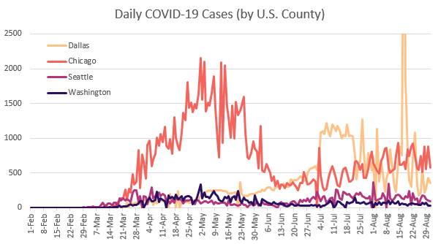

survey

Figure 2. Aggregate travel trends by mode during COVID-19 in four U.S. metropolitan areas

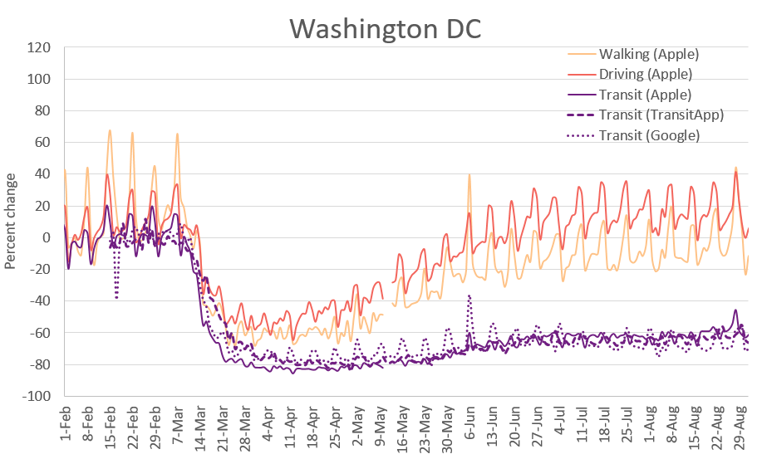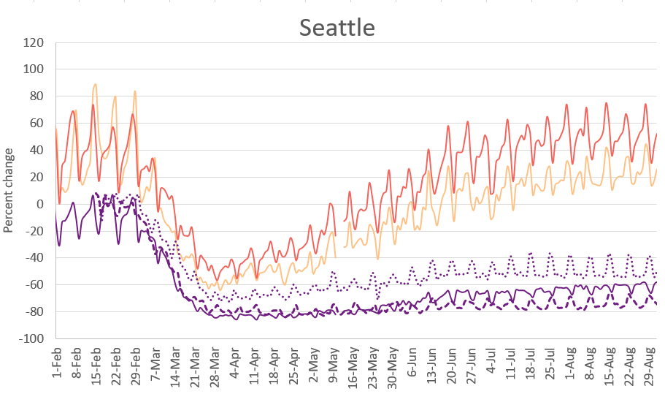

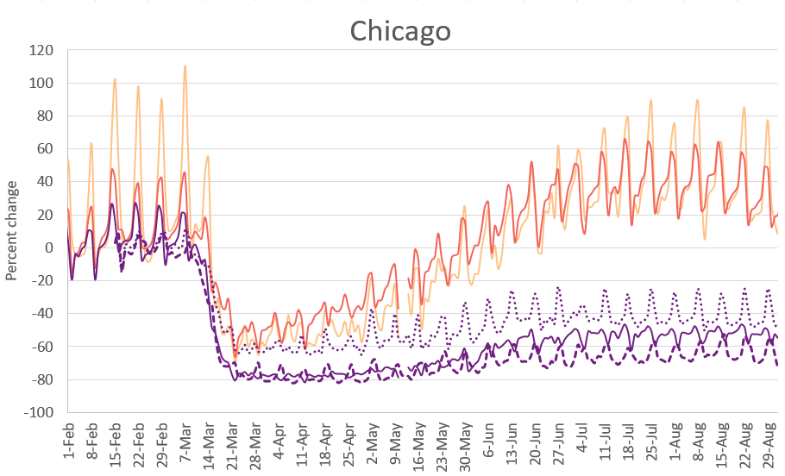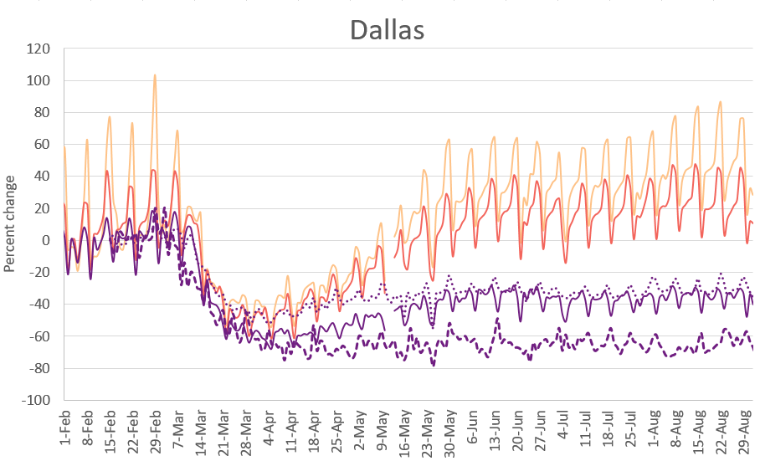

*Notes:* Data from Apple Maps represent daily volume of direction requests by mode compared to baseline volumes from January 13, 2020. Data from Transit App shows actual use of the app compared to projected use of the app based on 2019 numbers (adjusted for annual growth rate). Data from Google Maps provides number of visits per day at transit stations compared to the median value for the corresponding day of the week during the 5-week period from January 3 to February 6, 2020; data are only from users opted into location history for their Google Accounts. No demographic information accompanies any of this data, so we cannot assess their representativeness of the metropolitan area populations.

## Survey Design

We undertook an online survey with two distinct types of discrete choice experiments: single binary discrete choice (SBDC) (Loomis et al., 1998) and best-worst scaling (BWS) (Louviere et al., 2013). In the following sections, we provide details on the experimental design, analytic approach, and results for each of these choice experiments. While our data collection protocol prohibits us from publishing the raw data records, the full questionnaire, analysis code, and results are available at: <https://github.com/jcmoody6/car-value>.

# Single Binary Discrete Choice (SBDC)

## Experimental Design

The single binary discrete choice (SBDC) experiment asked respondents to make a single choice from two options: keep access to a transportation option or forego access in return for a specific amount of compensation. Different scenarios were created to measure the value of private car ownership and use compared to ride-hailing:

1. Value of ride-hailing: Given all your travel needs and options**,** choose whether to give up access to **ride-hailing** for one year and receive a compensation amount, or keep access to ride-hailing and receive no compensation.
2. Value of car ownership and use: Given all your travel needs and options, choose whether to give up access to your **primary car** for one year and receive a compensation amount, or keep access to your car and receive no compensation.
3. Value of car ownership: You are given access to a **new, free, ubiquitously available ride-hailing service** that can serve all of the trips that you currently make by your primary vehicle without any additional inconvenience. Choose whether to give up access to your **primary car** for one year and receive this free service and a compensation amount, or keep access to your car and receive no compensation nor free ride-hailing.

Then from the difference between scenarios 2 and 3, we can isolate the value of car use. See the full “Questionnaire” at the end of this document for exact wording of the scenarios and how they the choice experiments are presented to the respondent.

Each respondent was randomly presented with four compensation amounts randomly selected from a pre-determined set for each scenario (Table 3). For one set of scenarios, all respondents were asked to recall their typical travel behavior in a year pre-COVID-19 (for example, 2019). For a second set of scenarios, all respondents were asked to answer for a month during COVID-19 (for example, June 2020) with the monetary amounts adjusted to be approximately 1/12 those provided for the typical year. Compensation amounts were determined prior to the start of data collection through a review of existing literature on costs of car ownership and use and a pilot survey with 200 responses conducted in February 2020 on Amazon’s MechanicalTurk platform.

Table 3. Compensation amounts used in the SBDC scenarios

|  |  |  |
| --- | --- | --- |
| Scenario | COVID period | Set of possible compensation amounts ($) |
| Scenario 1. Value of ridehailing | Typical year pre-COVID  Month during COVID | 25; 50; 100; 250; 500; 750; 1,000; 2,500; 5,000; 7,500; 10,000; 12,500  2; 4; 8; 20; 40; 60; 80; 200; 425; 650; 800; 1,000 |
| Scenarios 2 and 3. Value of car ownership and use | Typical year pre-COVID  Month during COVID | 100; 500; 1,000; 2,000; 3,000; 4,000; 5,000; 7,500; 10,000; 15,000; 20,000; 25,000; 30,000; 40,000; 50,000; 75,000  10; 40; 80; 150; 250; 300; 400; 625; 800; 1,250; 1,500; 2,000; 2,500; 3,000; 4,000; 6,250 |

### Ridehailing Explanation

To address the fact that ridehailing may not be universally understood or experienced, we provided each respondent a clear definition of “ride-hailing” in the survey text. In addition, we also asked respondents for their ridehailing use. Borrowing a question from the National Household Travel survey, we asked respondents whether they had ever used a “taxi service or a smartphone ride-hailing app (e.g., Uber, Lyft, or Via).” Respondents who indicated they had not used ride-hailing before were not presented with Scenario 1 for the SBDC questions. The text of Scenario 1 similarly described ride-hailing services as “including Uber, Lyft, and taxi” (see full Questionnaire at end of this document).

## Analytic Approach

SBDC questions are compatible with economic theory and random utility models. Therefore, we can use a logistic regression to measure the surplus that individual consumers obtain from access to different transportation options and the monetary value that they attach to them. Specifically, we represent the utility that a consumer experiences from a transportation option *t* by *U(t)*. In our SBDC questions, utility is only affected by a change in access to the transportation option, with quantities restricted to 1 and 0, i.e., a consumer can either access a good within a defined time period *(t1)* or not *(t0)*. We assume that *U(t1) ≥ U(t0)* or that customers derive a non-negative utility from accessing the transportation option (and would otherwise not use it.

Following Brynjollfson, Eggers, and Collins (2018), we estimate two logistic regression models to estimate the willingness to accept compensation (WTAC) for access to the transportation options in each of our scenarios. The first logistic regression (our base model) contains only the compensation amount and a random intercept term. The second logistic regression (our model with socio-demographics) includes additional predictors in the choice whether or not to give up access to the transportation option for a year—such as characteristics of the respondent, his/her household, and the built environment. Both models include panel effects to control for the fact that each respondent in our survey answered four choices for each scenario and therefore the error terms of these choices may be correlated with one another.

### Base Model

For our base model, we model the choice to give up access to a transportation option, *t* (choice = 1) in exchange for a given compensation amount *C* ($) or to keep access to the transportation option and forgo the money (choice = 0). We model the binary choice variable as a function of a random intercept and the logarithmic transformation of the compensation amount, *log(C)*, using a logistic regression where $p_{i}$ is the probability that individual *i* gives up transportation option *t*:

$$\log\left(\frac{p_{i}}{1-p_{i}}\right)=β_{0,i}+β_{c}\log\left(C\right)+ε_{i}$$

We estimate the mean of the random intercept $β_{0,i}$ and $β_{c}$ using the *pglm* package in R (Croissant, 2020b) and then solve for the median WTAC for access to *t* by setting $p_{i}$ equal to 0.5 and solving for *C*:

$$\log\left(\frac{0.5}{1-0.5}\right)=\overline{β_{0,i}}+\hat{β_{c}}\log\left(C\right)$$

$$\log\left(1\right) or 0=\overline{β_{0,i}}+\hat{β_{c}}\log\left(C\right)$$

$$-\frac{\overline{β_{0,i}}}{\hat{β_{c}}}=\log\left(C\right)$$

$$C=e^{\frac{-\overline{β_{0,i}}}{\hat{β_{c}}}}$$

This provides a point estimate of the compensation amount associated with indifference between giving up and keeping access to the transportation option for the entire sample. We estimate this separately for each of the SBDC scenarios to measure the WTAC for ridehailing, car ownership and use together, and car ownership separately.

### Model with Socio-demographics

Next, we want to understand. We have a vector of socio-demographic characteristics $x_{i}$ for each individual *i* in our sample. Including these as predictors in our logistic regression, we can estimate:

$$\log\left(\frac{p_{i}}{1-p_{i}}\right)=β_{0,i}+β_{c}\log\left(C\right)+{β_{x}x_{i}+ε}_{i}$$

Estimating this model, we get a set of coefficients that are general, but since each individual has their own socio-demographic characteristics, when plugging in *p = 0* we solve for an individual-specific “indifference compensation” that we call $C_{i}$:

$$\log\left(\frac{0.5}{1-0.5}\right)=\overline{β_{0,i}}+\hat{β_{C}}\log\left(C\right)+\hat{β_{x}}x_{i}$$

$$C_{i}=e^{-\frac{\overline{β_{0,i}}+\hat{β_{x}}x_{i}}{\hat{β_{c}}}}$$

The result is no longer a point estimate, but instead a distribution of $C_{i}$ at the indifference point *p = 0.5* for every individual *i*. We can take the median (or mean) of this distribution across individuals to get a point estimate similar to the median WTAC calculated in the base model. However, this result now accounts for the socio-demographics of the individuals that make up our sample. One benefit of having this individual-specific indifference compensation amount is that we can compare these values across subsamples of our data. For example, we can look at how the median or mean $C_{i}$ among urban residents differs from the value for suburban or rural residents, controlling for the other sociodemographic characteristics of these groups.

The results for the base model and the model with socio-demographics are reported in the manuscript for all pre-COVID (typical year) scenarios. The results for the base model only are presented for the month during-COVID scenarios.

## Base Model Robustness Checks

In this section, we explore the potential impact of alternative modeling specifications/approaches on the results of our base model during the pre-COVID (typical year) scenarios—reported in Table 1 of the manuscript. In particular, we consider how the overall fit of the model and our estimates of median WTAC vary when 1) a random rather than fixed coefficient for log(C) is estimated and 2) when survey weights are included in the model estimation to account for non-representativeness. The *pglm* package in R used to estimate the main results presented in the manuscript is unable to estimate these alternative model specifications, so these robustness checks were run in Mplus (Muthén and Muthén, 1998-2019). Results are presented in Table 4 below.

Table 4. Model results when including survey weights (“weighted”), a random coefficient for the compensation amount (“mix”), and the combination thereof.

|  |  |  |  |  |
| --- | --- | --- | --- | --- |
| **Value** | **Base model, unweighted** | **Base model, weighted** | **Mix model, unweighted** | **Mix model, weighted** |
| **Scenario 1. Ridehailing\*** | | | | |
| Intercept | -3.663 (0.174) | -4.236 (0.287) | -4.081 (0.183) | -4.784 (0.308) |
| Coefficient of log(C) | 0.760 (0.029) | 0.849 (0.049) | 0.858 (0.033) | 0.976 (0.056) |
| Median WTAC best estimate | $124 | $147 | $116 | $66 |
| AIC | 10841 | 10530 | 10786 | 10448 |
| BIC (sample size-adjusted) | 10853 | 10542 | 10802 | 10464 |
| **Scenario 2. Car ownership and use\*\*** | | | | |
| Intercept | -10.429 (0.376) | -11.187 (0.587) | -10.445 (0.367) | -11.169 (0.595) |
| Coefficient of log(C) | 1.119 (0.040) | 1.192 (0.063) | 1.120 (0.039) | 1.192 (0.063) |
| Median WTAC best estimate | $11,158 | $11,909 | $11,223 | $11,731 |
| AIC | 15302 | 14905 | 15304 | 14905 |
| BIC (sample size-adjusted) | 15316 | 14918 | 15322 | 14922 |
| **Scenario 3. Car ownership only\*\*** | | | | |
| Intercept | -10.381 (0.381) | -12.016 (0.649) | -10.384 (0.381) | -12.008 (0.600) |
| Coefficient of log(C) | 1.182 (0.042) | 1.353 (0.072) | 1.184 (0.042) | 1.352 (0.066) |
| Median WTAC best estimate | $6,520 | $7,194 | $6,440 | $7,199 |
| AIC | 15015 | 14554 | 15015 | 14556 |
| BIC (sample size-adjusted) | 15028 | 14567 | 15033 | 14573 |

### Random Coefficient for Compensation (“Mix model”)

First, we consider whether respondents have significant unobserved heterogeneity in their response to the compensation levels shown in the choice experiments. We estimate the base model in all three of our pre-COVID (typical year) scenarios introducing a random coefficient for the log(C) term (in addition to the random intercept already included in the base model specification to control for panel effects). Comparing the AIC and BIC indicators of model fit between our base model and this “mix model”, we find that there is no improvement in model fit from adding a random coefficient for log(C). And there only small changes in the estimated median WTAC.

### Incorporating Sample Weights (“weighted”)

Second, since there is a difference between the sample and the population in certain demographic categories (see Table 2 in SI) we consider the impact of including survey weights in the model estimation. First, raking (iterative proportional fitting, IPF) was used to calculate survey weights so that the sample matched the population in terms of gender, household income brackets, household size, household car ownership, and education levels for each of the four metropolitan area subsamples. Due to quota sampling, there was not enough discrepancy between our sample and the population in terms of age brackets to include these in the IPF. Survey weights were calculated using the *anesrake* package in R (Pasek, 2018), which implements the American National Election Study (ANES) weighting algorithm documented in (DeBell and Krosnick, 2009). Survey weights were scaled so that the product of the between and the within weights sums to the total sample size (Carle, 2009; Asparouhov and Muthén, 2008; Rabe-Hesketh & Skrondal, 2006).

The weighted model better accounts for the fact that households with low education, low and high income, only one person, or with three or more vehicles are under-sampled. Compared to our unweighted base model, we find that including the survey weights meaningfully improves the overall model fit in terms of AIC and BIC for all three of our pre-COVID (typical year) scenarios (see Table 4). We find that including survey weights results in slightly higher median WTAC estimates for ridehailing (Scenario 1), car ownership and use (Scenario 2), and car ownership only (Scenario 3). This suggests that some of the sociodemographic groups underrepresented in our online sample require greater compensation to give up access to ridehailing or their car for a year. The results of the weighted model show that our estimates from the base model are, if anything, slightly conservative.

## Supplementary Results

Several figures and results are not central to the main conclusions of the paper, but provide additional context and detail to the findings.

### Individual-specific Indifference Compensation

Finding 1 of the manuscript discusses how, across our entire sample, people value owning a car more than it costs. However, we might also expect significant heterogeneity in median willingness to accept compensation. Therefore, using our model with socio-demographic characteristics, we estimate individual-specific indifference compensations, *Ci*, as discussed above. Here we focus on the results of from SBDC Scenario 2 (valuing car ownership and use). We find that there is a distribution in indifference compensation: 1st quartile = $7,395, median = $12,317, mean = $13,827, and 3rd quartile = $18,731.

We can compare each individual’s estimated indifference compensation to how much they report their household spends on car ownership and use in a typical month (divided by the number of cars in the household) (see Figure 2). We find that 80% of respondents in the sample were estimated to value car ownership and use more than they reported it costs them (above the line y = x). And even if the individuals underestimate the costs of their household vehicles by as much as 50% (Andor et al. 2020), 75% of individuals still value their car more than it costs (above the line y = 1.5x).

Figure 3. Scatterplot of estimated car ownership and use value versus self-reported car costs

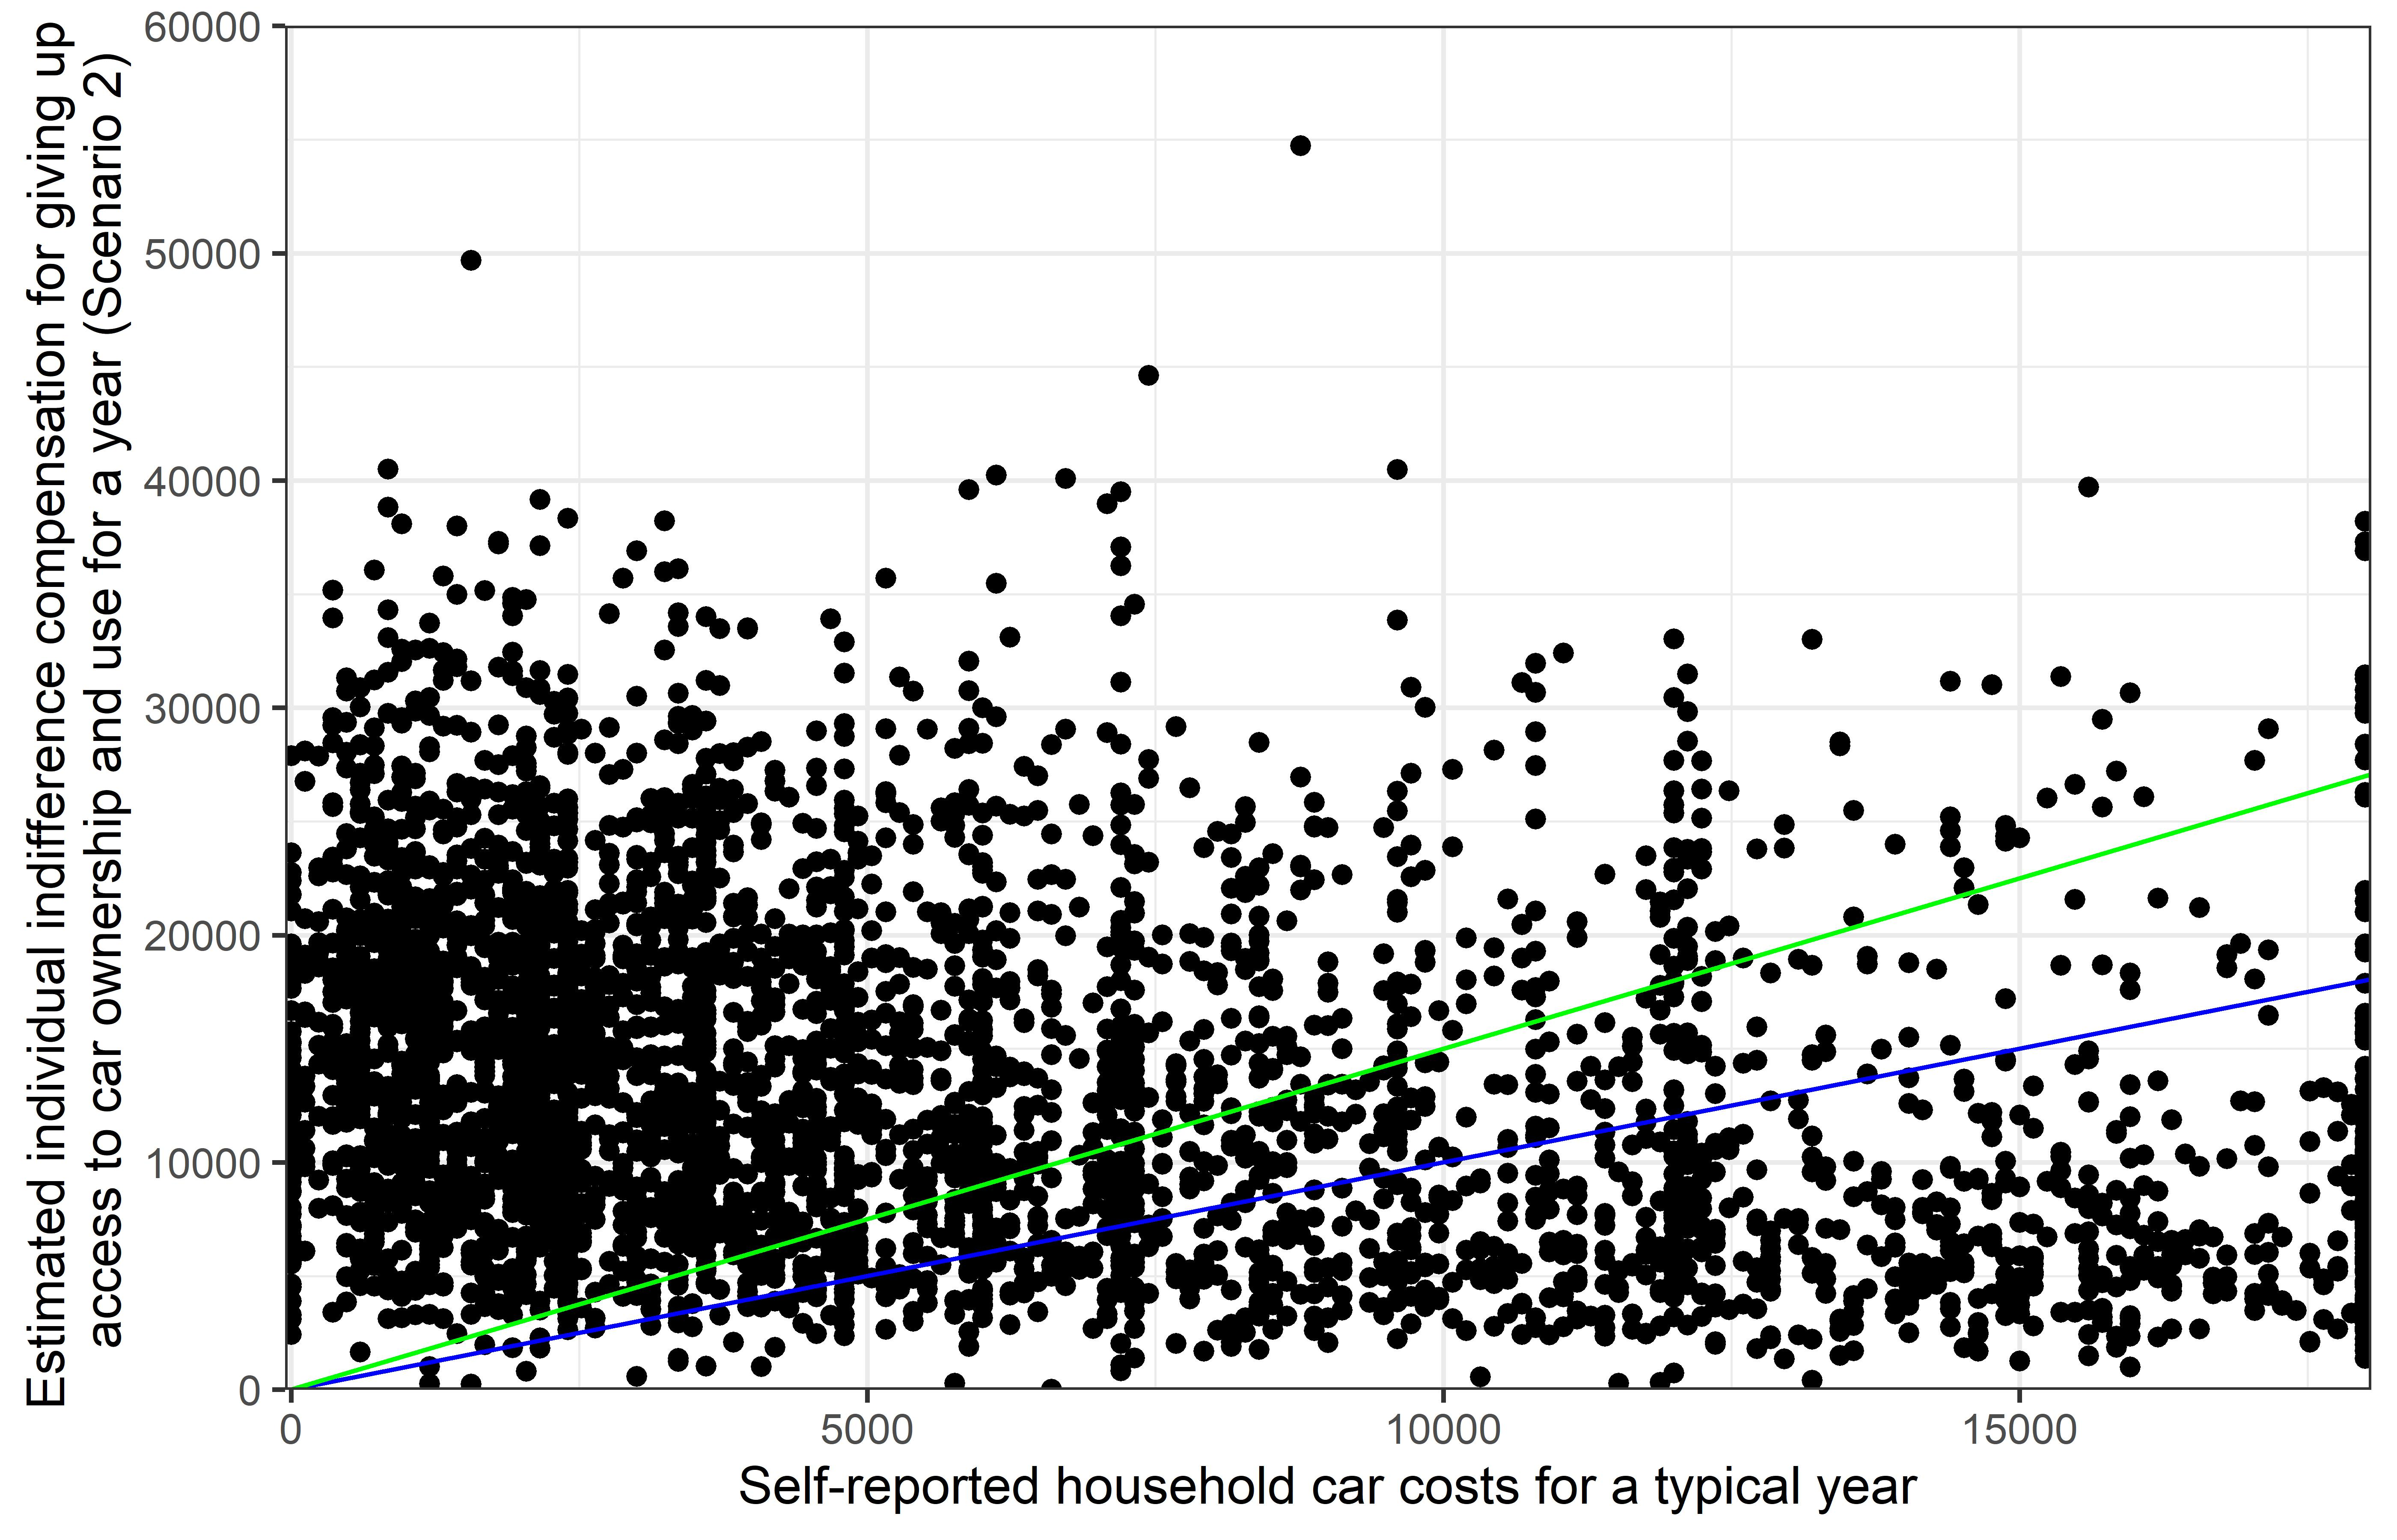

* **y = x**
* **y = 1.5x**

### Potential Components of Car Value

To provide additional nuance to the findings regarding the value of car ownership and use, we asked respondents why they would be reluctant to give up their primary vehicle. In hindsight, the list of options presented to respondents was likely not comprehensive and may not fully capture the breadth of symbolic and affective motives for car ownership and use evidenced in the literature (e.g., Moody, 2019; Gatersleben, 2007; Hunecke et al., 2007; Steg et al., 2001a; 2001b). Despite this limitation, the three most popular options chosen (by a large margin) all include some element of the “option value,” including the control, certainty and reliability, and flexibility it provides (see Figure 3). Other reasons were also common, indicating that the value placed on car ownership includes not only option value, but also the value of comfort, privacy, security, and speed, as well as other features.

Figure 4. Distribution of responses to the question “What are the three most important reasons why you would be reluctant to give up your primary vehicle?”

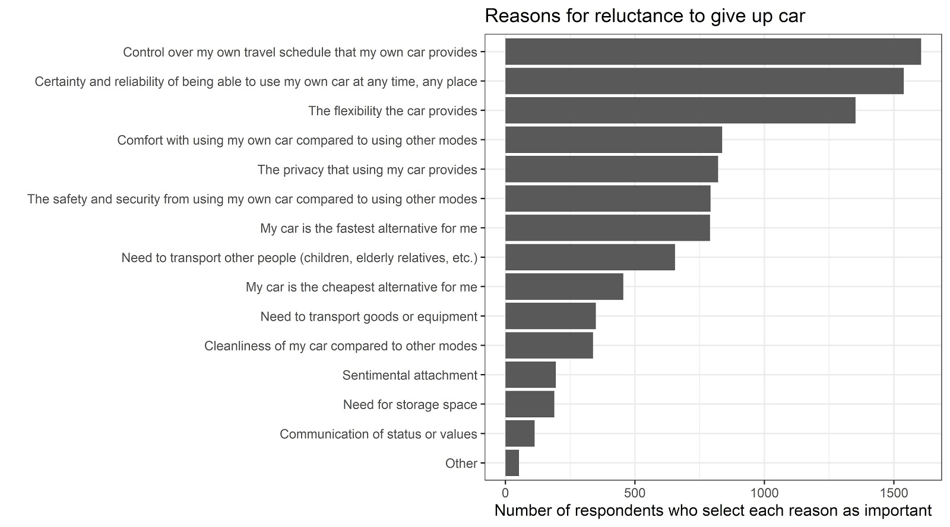

### Impacts of Built Environment

Finally, in Finding 4 of the main paper we show that living in an urban zip code is correlated with being more willing to give up one’s car as compared to living in a suburban or rural zip code. Specifically, each increase in the built environment category reduces the median value of owning and using a car by nearly $4,000 (Figure 4, top). Furthermore, having controlled for the urbanity of the respondents’ zip codes and their other sociodemographic characteristics, our models suggest that there is generally no statistically significant difference in willingness to give up access to a private car or ridehailing across cities. Summary statistics similarly show only small differences in the distribution of indifference compensation across individuals when grouped by city (Figure 4, bottom).

Figure 5. Boxplots of distribution of individual-specific indifference compensation for SBDC Scenario 2 for individuals grouped by rural, suburban, and urban home zip codes (top) and by metropolitan area (bottom). Median values in black, mean values in blue.

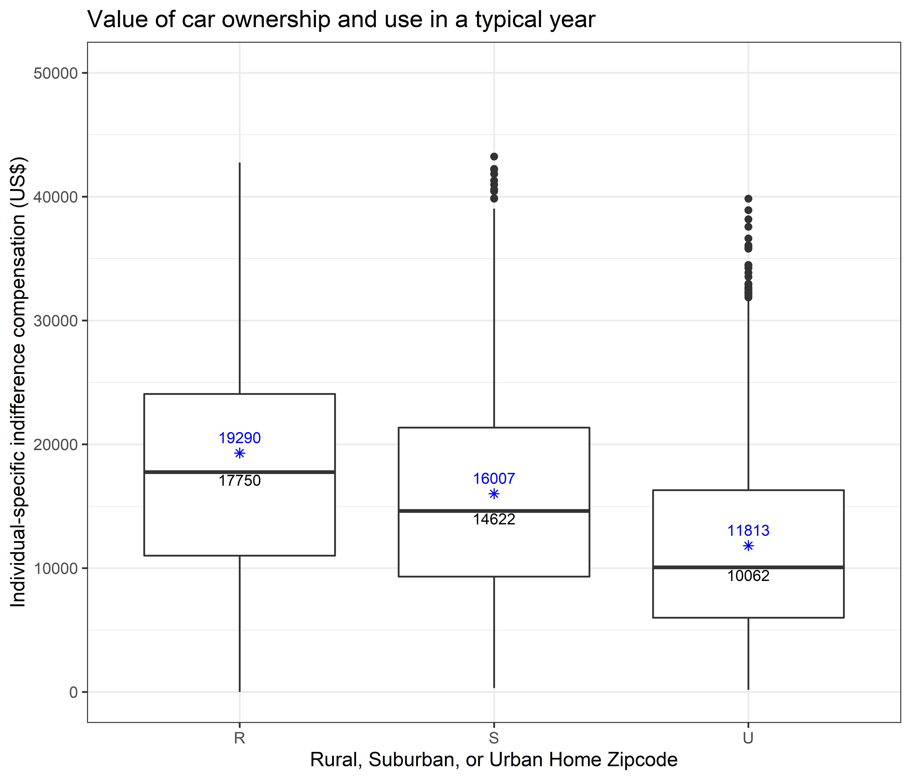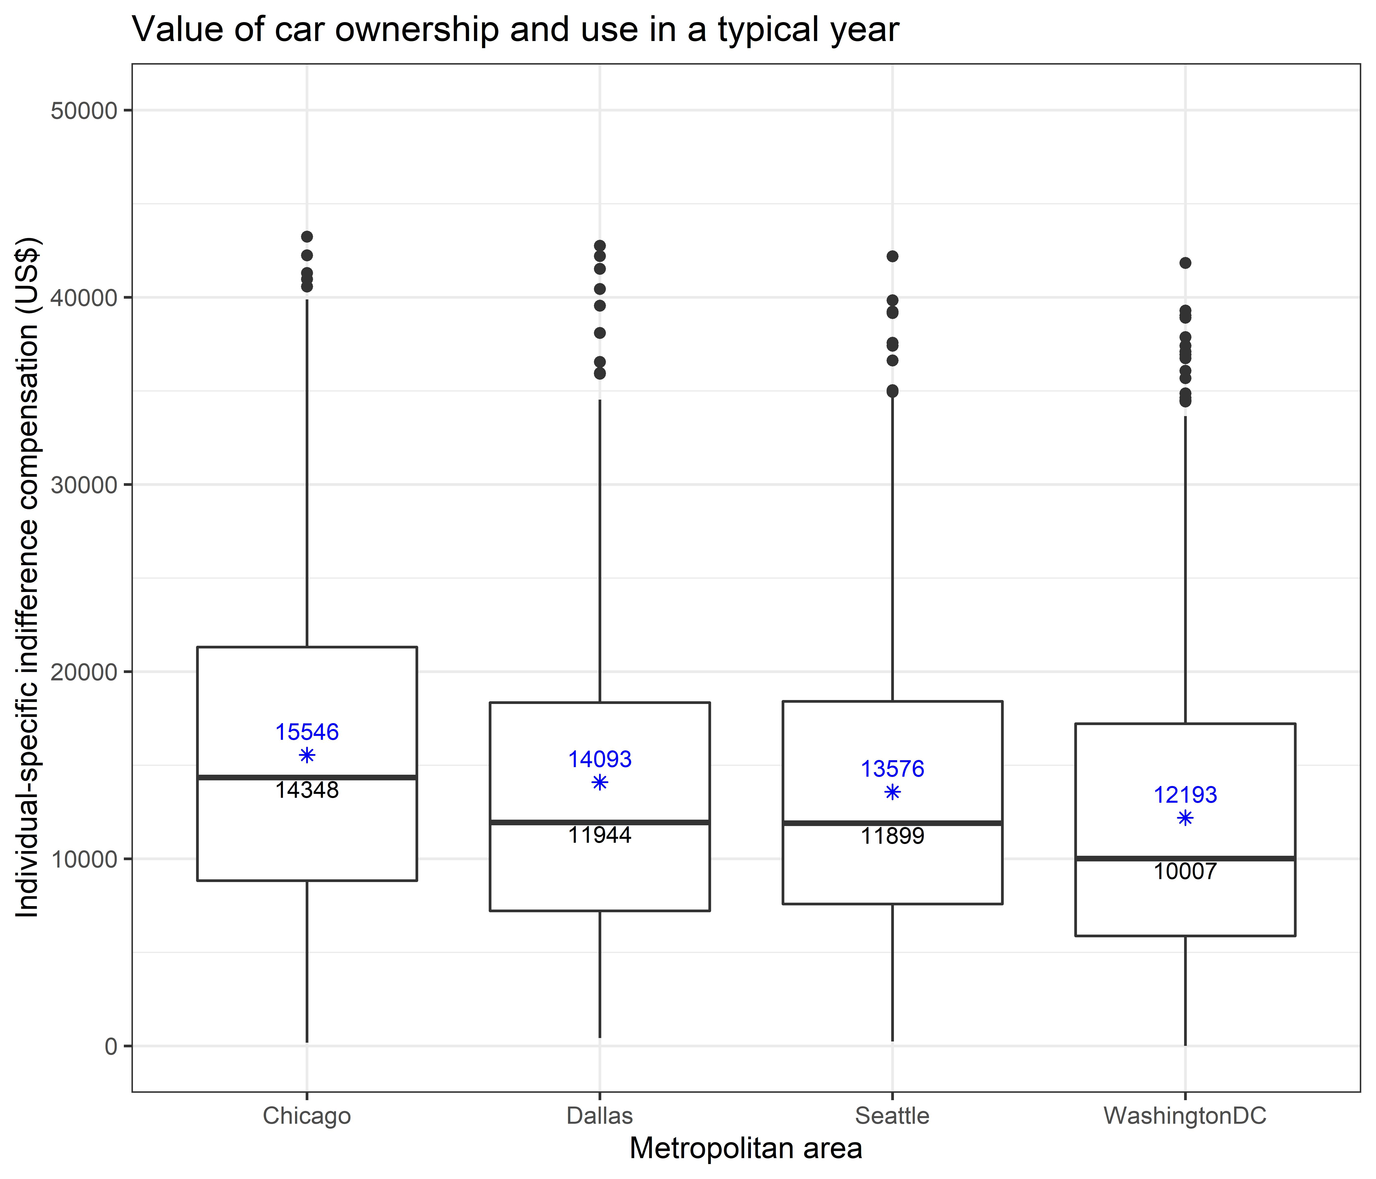

# Benchmarking the Single Binary Discrete Choice (SBDC) Measures with Best-Worst Scaling (BWS)

In addition to the single binary discrete choice experiments, we also conducted choice experiments based on the best-worst scaling (BWS) or maximum difference scaling approach (Finn and Louviere, 1992) following the benchmarking method used by Brynjolfsson, Collis, and Eggers (2019). We employ case 1 or object case BWS choice tasks, which ask respondents to select the best (most important) and worst (least important) options from a set of alternatives (Mühlbacher et al. 2016; Louviere et al., 2013).[1] Collecting more information for each respondent, both within the choice set and across sequential choice sets, makes this approach more efficient than SBDC, which elicits only one decision. Furthermore, individuals are required to make a tradeoff when deciding which good they perceive as most and least valuable, which helps mitigate or even eliminate hypothetical bias with respect to the ordinal ranking of the choices.

## Experimental Design

Before the BWS portion of the survey began, respondent were randomly assigned to either a pre-COVID scenario (typical year in 2019) or a during COVID scenario (one month like June 2020). Then each respondent answered 10 randomly selected questions. For each question, respondents were asked to select the best and worst option among a set of three options: a mobility option, a non-mobility or other option taken from Brynjolfsson, Collis, and Eggers (2019), and a monetary amounts.

The options for the pre-COVID typical year scenario are given in Table 5. Because we examined the value of foregoing access to specific mobility goods or services for one year, the monetary options were also expressed as losses (e.g., earning a specific amount of money less for one year) in order to be comparable. The price sensitivity we are measuring is therefore closer to WTP than WTA.

In the following sections and the main manuscript, we present only the analysis and results from the pre-COVID scenario. Therefore, these results are estimated from a randomly selected subsample of 2,014 individuals who each answered 10 BWS questions.

Table 5. Choice set for best-worst scaling choice experiments

|  |  |  |
| --- | --- | --- |
| Mobility | Other | Monetary |
| 1. No access to personal car 2. No access to bus 3. No access to train 4. No access to exclusive ride-hailing services (e.g., UberX or Lyft Classic) 5. No access to pooled ride-hailing services (e.g., UberPOOL or Lyft Shared) 6. No access to personal bike 7. No access to airline travel 8. No access to bike or scooter share 9. No access to car rental or car sharing (e.g., Zipcar) | 1. No toilets in the home 2. No TVs in the home 3. No access to all e-mail services 4. No access to online maps 5. No access to a smart phone 6. No access to a personal computer or laptop 7. No meeting with friends in person | 1. Earning $100 less 2. Earning $200 less 3. Earning $500 less 4. Earning $1,000 less 5. Earning $2,000 less 6. Earning $5,000 less 7. Earning $10,000 less 8. Earning $15,000 less 9. Earning $20,000 less |

## Analytic Approach

There are two approaches for analyzing responses to case 1 BWS questions: the counting approach and the modeling approach. The counting approach calculates several types of scores on the basis of the number of times each item is selected as the best or worst item among all the questions across respondents (Finn and Louviere, 1992; Lee, Soutar, and Louviere, 2007). For aggregate statistics, one can count the total number of times that each option is chosen as best and worst across all questions (choice sets) and individuals. Dividing these counts by the number of times the option appeared in the choice sets provides metrics of proportion best and proportion worst (see Table 5). Once can also calculate the difference in the best and worst counts (best minus worst, B-W). This B-W score has been shown to correlate well with revealed preferences and predict real behavior comparably with more sophisticated regression models (Louviere and Islam, 1006; Louviere et al., 2013).

In addition to the counting approach, one can use a discrete choice modeling approach to analyze responses based on utility maximization theory. There are three discrete choice models that are commonly used to assess case 1 BWS data: the maxdiff or paired model, the marginal model, and the marginal sequential model (Marley and Louviere, 2005; Flynn et al., 2007; Louviere, Flynn, and Marley, 2015). All three models are based on utility maximization theory, assuming that respondents derive utility for each item in a choice set $C$. From the $m$ items in the choice set, the respondent selects item $i$ as the best item and item $j$ as the worst item, where $i≠j$. The three models generally assume that the utility for the item selected as the worst is the negative of the one selected as the best.

Table 6. Best-worst scaling summary statistics ordered by difference in the best and worst counts; mobility options indicated with grey fill

|  |  |  |  |
| --- | --- | --- | --- |
| Option | Proportion best | Proportion worst | Best – worst |
| No toilets in the home | 0.057 | 0.704 | -1869 |
| No access to a smart phone | 0.115 | 0.481 | -1048 |
| No access to a personal computer or laptop | 0.129 | 0.475 | -980 |
| Earning $20,000 less | 0.172 | 0.553 | -835 |
| No access to all e-mail services | 0.136 | 0.419 | -827 |
| Earning $15,000 less | 0.174 | 0.538 | -822 |
| Earning $10,000 less | 0.173 | 0.533 | -792 |
| No meeting with friends in person | 0.168 | 0.374 | -594 |
| Earning $5,000 less | 0.196 | 0.460 | -591 |
| No TVs in the home | 0.184 | 0.358 | -501 |
| Earning $2,000 less | 0.191 | 0.392 | -469 |
| No access to personal car | 0.235 | 0.409 | -392 |
| Earning $1,000 less | 0.208 | 0.368 | -358 |
| Earning $500 less | 0.258 | 0.311 | -119 |
| No access to online maps | 0.232 | 0.255 | -68 |
| Earning $200 less | 0.263 | 0.284 | -45 |
| Earning $100 less | 0.286 | 0.250 | 81 |
| No access to airline travel | 0.622 | 0.143 | 1066 |
| No access to pooled ride-hailing services | 0.690 | 0.129 | 1262 |
| No access to car rental or car sharing | 0.689 | 0.127 | 1264 |
| No access to exclusive ride-hailing services | 0.695 | 0.129 | 1269 |
| No access to bus | 0.689 | 0.114 | 1312 |
| No access to personal bike | 0.700 | 0.105 | 1339 |
| No access to train | 0.723 | 0.107 | 1347 |
| No access to bike or scooter share | 0.728 | 0.105 | 1370 |

The models differ in how they assume that respondents select the best and worst items from the choice set. The maxdiff model assumes that respondents make their selections of best and worst items based on the greatest utility difference among the options.[2] The marginal model assumes that respondents simultaneously select item $i$ as the best item and item $j$ as the worst item from *m* possible items. Therefore, the model assumes that the utilities for items $i$ and $j$ are the maximum and minimum, respectively, among the utilities of all $m$ items. Finally, the marginal sequential model assumes that respondents first select item $i$ as the best item from $m$ items and then select item $j$ as the worst item from the remaining $m-1$ items.

Under these assumptions, the probability of selecting item $i$ as the best and item $j$ as the worst from a choice set C for each model can be expressed using a conditional logit model with the systematic component of utility $V$, as follows:

$P\left(\text{best}=i, \text{worst}=j\right)=\frac{e^{{(V}_{i}-V_{j})}}{\sum_{k,l∈C, k≠l}{e^{{(V}_{k}-V_{l})}}}$ (1)

$P\left(\text{best}=i, \text{worst}=j\right)=\frac{e^{{(V}_{i})}}{\sum_{k∈C}{e^{(V_{k})}}}\frac{e^{(-V_{j})}}{\sum_{k∈C}{e^{{(-V}_{k})}}}$ (2)

$P\left(\text{best}=i, \text{worst}=j\right)=\frac{e^{{(V}_{i})}}{\sum_{k∈C}{e^{{(V}_{k})}}}\frac{e^{(-V_{j})}}{\sum_{l∈C-i}{e^{(-V_{l})}}}$ (3)

In this study, we choose to estimate our case 1 BWS conditional logit using the maxdiff model described in equation (1). We estimate the utility parameters (coefficients) using the *mlogit* package in R (Croissant, 2020a) following an example by Aizaki (2019). This estimation leads to interval-scaled scores that represent the disutility of not having access to a good (or earning an amount less in income) for one year (Figure 6).

## Results

From Figure 6, we see that individuals rank losing access to personal car for a year between earning $10,000 and $20,000 less for a year. When it comes to access to other mobility options, including airline travel, car rental, ride-hailing, public transit, and bikes/scooters are valued at less than $100 for a year. This finding agrees with results from Brynjolfsson, Collis, and Eggers, who found that, among a sample of U.S. respondents, access to airline travel for a year was valued between $5 and $10, access to public transportation for a year was valued at $1 and $5, and access to ride sharing services and Uber were valued at less than $1 for a year (2019).

To translate estimated disutilities into monetary amounts, we can estimate an equation of best fit between the loss of the monetary amounts provided and their estimated disutility as in Figure 7. We can then use this equation to calculate the monetary equivalent of the disutilities estimated for the mobility and other goods included in the BWS model. These results are presented in Table 7, which provides an estimate for the value of one year of access to a personal car of $16,890 with a standard error of around $100.

Figure 6. Disutility of losing an option for a year based on BWS maxdiff model estimation; all results are relative to earning $100 less per year set to disutility = 0.

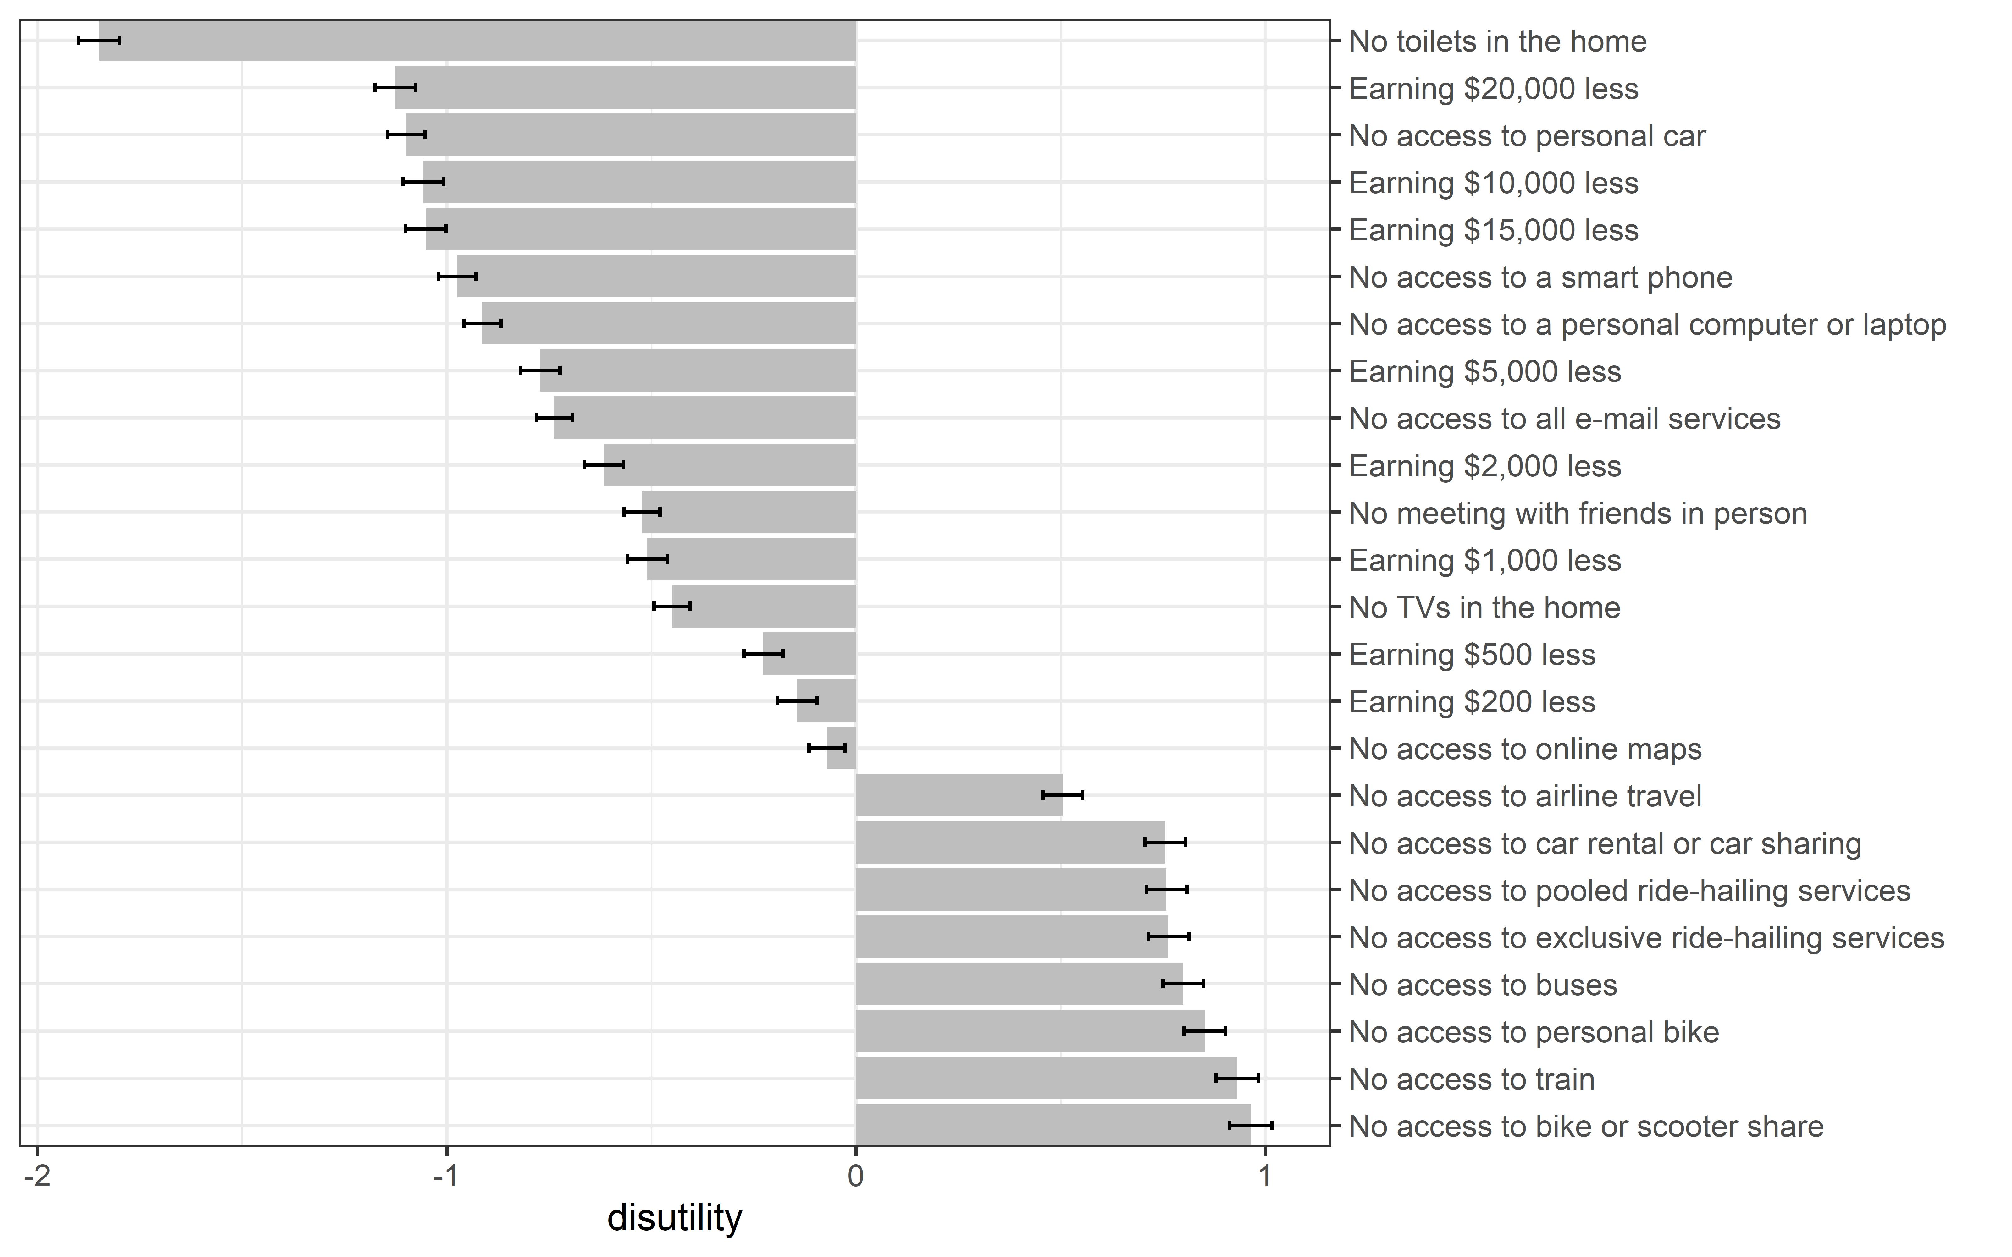

Figure 7. Exponential equation of best fit between monetary loss and estimated disutility from the BWS maxdiff model

Table 7. Estimated disutilities and their extrapolated monetary amounts from the BWS experiment

|  |  |  |  |
| --- | --- | --- | --- |
| Option | Disutility estimate | Standard error | Calculated value ($) |
| No toilets in the home | -1.850 | 0.049 | 494,664 |
| No access to personal car | -1.099 | 0.046 | 16,890 |
| No access to a smart phone | -0.975 | 0.045 | 9,649 |
| No access to a personal computer or laptop | -0.913 | 0.045 | 7,326 |
| No access to all e-mail services | -0.737 | 0.044 | 3,316 |
| No meeting with friends in person | -0.523 | 0.044 | 1,267 |
| No TVs in the home | -0.450 | 0.044 | 911 |
| No access to online maps | -0.072 | 0.044 | 166 |
| No access to airline travel | 0.504 | 0.049 | 12 |
| No access to car rental or car sharing | 0.754 | 0.050 | 4 |
| No access to pooled ride-hailing services | 0.758 | 0.050 | 4 |
| No access to exclusive ride-hailing services | 0.763 | 0.050 | 4 |
| No access to buses | 0.799 | 0.050 | 3 |
| No access to personal bike | 0.851 | 0.050 | 3 |
| No access to train | 0.930 | 0.051 | 2 |
| No access to bike or scooter share | 0.963 | 0.051 | 2 |

## Robustness Check: Fatigue Analysis

While previous literature recommended the use of attention checks or fixed-choice questions embedded in between the survey choice tasks to ensure that respondents are accurately reading and selecting options (e.g., Carson et al., 1994), more recently there has been significant debate over the effectiveness and potential consequences of their use. Studies have found that excluding participants who fail attention checks can harm data quality by introducing demographic and response biases into the sample (Vanette, 2017; Abbey and Meloy, 2017) and, in some cases, can actually change participant’s behavior in the study (Hauser and Schwarz, 2015) although results there are mixed (e.g, Gummer, Roßmann, and Silber, 2018). Given concerns about response representativeness and potential selection bias with the use of fixed-choice attention checks, we chose not to implement them in our survey design. Instead, we opted to include quality screening questions at the beginning and end of the survey:

We care about the quality of our data. In order for us to get the most accurate measures of your opinions, it is important that you thoughtfully provide your best answers to each question in this survey.   
Do you commit to thoughtfully provide your best answers to each question in this survey?

* I will provide my best answers [only participants who select this response can continue]
* I will not provide my best answers
* I can't promise either way

Thank you for participating in this survey.  
Have you read all the questions fully and answered honestly?

* Yes [only participants who selected this response are included in analysis]
* No

All model results are presented only for those who met these quality checks.

Given the complexity of the BWS choice experiment, the fact that respondents were asked to answer 10 choices in a row, and the fact that these questions came toward the end of the survey for all respondents, there is potential concern of respondent fatigue and inattention. To explore whether fatigue may have impacted the results of our model post-hoc, we compare the estimates from all 10 choices to the estimates from a model only using the first 5 (half) of the choices for each respondent. The resulting ranking of options by disutility estimated using the first half of the choices (Figure 8) was practically identical to what was achieved using the full sample (Figure 6). This mitigates concerns that respondents grew fatigued through the choice experiment.

Figure . Disutility of losing an option for a year based on BWS maxdiff model estimation for only the first half (5) choices; all results are relative to earning $100 less per year set to disutility = 0.

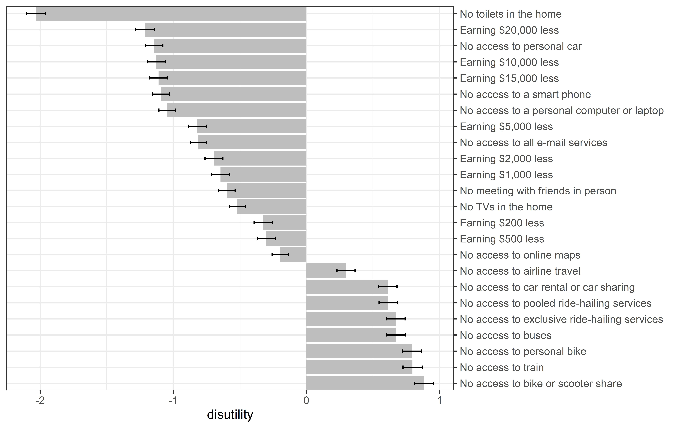

# Questionnaire

## Informed Consent

Thank you for your interest in participating in our research study! This study---conducted by researchers at the MIT Energy Initiative---collects information about your mobility options and travel choices under different scenarios.

**Procedure**

The study consists of a survey, which should take about 15 minutes to complete. The survey is best viewed on a larger-screen device such as a tablet or personal computer.

**Risks/Discomforts**

Risks are minimal for involvement in this study. However, you may feel emotionally uneasy when asked to pass judgment on certain questions.

**Benefits and Participation**

Participation in this research study is completely voluntary. Through your participation, researchers will learn more about how to meet the needs of travelers when providing varied transportation services.

You have the right to refuse to participate in this study or to withdraw at any time. If you desire to withdraw, please close your internet browser.

**Confidentiality**

This survey does not ask you for any information that can be used to identify you. All data obtained from participants will be kept strictly confidential and will only be reported in an aggregate format (as combined results), never as individual responses. The data collected will be stored in the HIPPA-compliant, Qualtrics-secure database until it has been deleted by the primary investigator. No one other than the primary investigator or assistant researchers listed below will have access to the data, unless additional permissions are received.

**Questions about the Research or about your Rights as Research Participants?**

If you have questions regarding this study, you may contact Dr. Joanna Moody at +1-434-409-5679 / jcmoody@mit.edu. Additional researchers on the study include Liza Farr (lfarr@mit.edu) and Prof. David R. Keith of the MIT Sloan School of Management (dkeith@mit.edu). If you have questions you do not feel comfortable asking the researcher listed above, you may contact MIT's Committee on the Use of Humans as Experimental Subjects (COUHES) via email at couhes@mit.edu or securely through the web at https://couhes.mit.edu/contact-us.

I have read and understood the above consent form and desire of my own free will to participate in this study

* Yes
* No

## Quota/Eligibility Screening Questions

First we would like to ask you a few questions about yourself and your household.

For the purposes of this survey, a household includes all the people who occupy a housing unit (such as a house or apartment) as their usual place of residence. A household includes the related family members and all the unrelated people, if any, such as lodgers, foster children, wards, or employees who share the housing unit. A person living alone in a housing unit, or a group of unrelated people sharing a housing unit such as partners or roomers, is also counted as a household.[3]

Please indicate your age: ________

[open text entry; must be number between 18 and 100]

What is your total annual household income?

[drop-down menu; single response]

* Less than $10,000
* $10,000 - $14,999
* $15,000 - $24,999
* $25,000 - $34,999
* $35,000 - $49,999
* $50,000 - $74,999
* $75,000 - $99,999
* $100,000 - $149,999
* $150,000 - $199,999
* $200,000 or more

How many cars does your household own?

[radio buttons; single response]

* Zero
* 1 car
* 2 cars
* 3 or more cars

Have you ever used a taxi service or a smartphone ride-hailing app (e.g., Uber, Lyft, or Via)?

* Yes
* No

## Car Pride

Please tell us about your attitudes towards **owning a car now and in the future**. If you do not own a car now, please answer the questions about general and future car ownership.

|  |  |  |  |  |  |  |  |
| --- | --- | --- | --- | --- | --- | --- | --- |
| ­­ | Strongly disagree | Disagree | Partially disagree | Neither agree nor disagree | Partially agree | Agree | Strongly agree |
| Having a car is connected with one's social image | ○ | ○ | ○ | ○ | ○ | ○ | ○ |
| I deserve to own and express myself with a great car | ○ | ○ | ○ | ○ | ○ | ○ | ○ |
| Others would see me as more successful if I owned a better car or more cars | ○ | ○ | ○ | ○ | ○ | ○ | ○ |
| I have achieved in life and therefore I deserve a good car | ○ | ○ | ○ | ○ | ○ | ○ | ○ |
| I feel owning a car is a positive component of my identity | ○ | ○ | ○ | ○ | ○ | ○ | ○ |
| I want to have a successful life and that includes owning a nicer car or more cars | ○ | ○ | ○ | ○ | ○ | ○ | ○ |

Please tell us about your **attitudes towards** **driving/using a car now and in the future**. If you do not drive a car now, please answer the questions about general and future car ownership.

|  |  |  |  |  |  |  |  |
| --- | --- | --- | --- | --- | --- | --- | --- |
| ­­ | Strongly disagree | Disagree | Partially disagree | Neither agree nor disagree | Partially agree | Agree | Strongly agree |
| Driving meets my self esteem or personal image | ○ | ○ | ○ | ○ | ○ | ○ | ○ |
| Driving a car makes me feel superior to those who don't | ○ | ○ | ○ | ○ | ○ | ○ | ○ |
| Driving a car positively affects my perception of myself  [Please select “somewhat disagree”] | ○ | ○ | ○ | ○ | ○ | ○ | ○ |
| I would love to be seen more often driving | ○ | ○ | ○ | ○ | ○ | ○ | ○ |
| If more people saw me in/with my car, I would drive more | ○ | ○ | ○ | ○ | ○ | ○ | ○ |
| I gain respect from my peers because I drive a car | ○ | ○ | ○ | ○ | ○ | ○ | ○ |

## Single Binary Discrete Choice: Typical Year

[Instructions shown to all respondents who will see at least one SBDC scenario—i.e., their household owns at least one car and they have used a taxi/ride-hailing service]

In the following pages, you will be presented with a series of scenarios regarding access to different travel alternatives. Please read each of these scenarios carefully before proceeding to the associated questions.

While answering these questions, please consider all of your travel needs and options throughout a typical year. **Please respond for a typical year not interrupted by a global pandemic**, for example, 2019.

### Scenario 1 – Ridehailing

[Shown only to those who responded that “Yes” they have used a taxi service or a smartphone ride-hailing app in the screening questions]

In the following four questions, you are offered a choice regarding your **access to ride-hailing services including Uber, Lyft, and taxi**. You can A) give up access to all ride-hailing services for a year and receive some specific amount of money in compensation, or B) keep your access to ride-hailing and forgo that sum of money.

Everything else about your typical yearly travel needs and options remains unchanged, including access to all other transportation services.

------

Q. Given all your travel needs and options in a typical year, which would you prefer?  
[radio buttons; single response]

* Keep access to ride-hailing services and receive no money
* Give up access to ride-hailing services for a year and receive [compensation]

[Each respondent answers 4 questions, each with a different compensation amount randomly selected from 12 possible values: {$25, $50, $100, $250, $500, $750, $1,000, $2,500, $5,000, $7,500, $10,000, $12,500}]

### Scenario 2 – Private Car

[Shown only to those who responded that their household owns at least one in the screening questions]

In the following four questions, you are offered a choice regarding **access to your** **primary vehicle**. If your household owns multiple vehicles, **your primary vehicle is the one you personally use most often**. If you use multiple vehicles equally, please choose one of these vehicles to consider and answer all questions in this survey for that vehicle of choice.

Given your typical yearly travel needs and options, you are asked to choose whether you would prefer to: A) give up access to your primary vehicle for a year and receive some specific amount of money in compensation, or B) keep your primary vehicle and forgo that sum of money.

Everything else about your typical yearly travel needs and options remains unchanged, including access to any other vehicle your household may own that is not your primary vehicle.

------

Q. Given all your travel needs and options in a typical year, which would you prefer?  
[radio buttons; single response]

* Keep access to my primary vehicle and receive no money
* Give up access to my primary vehicle for one year and receive [compensation]

[Each respondent answers 4 questions, each with a different compensation amount randomly selected from 16 possible values: {$100, $500, $1,000, $2,000, $3,000, $4,000, $5,000, $7,500, $10,000, $15,000, $20,000, $25,000, $30,000, $40,000, $50,000, $75,000}]

### Scenario 3 – Private Car with Ridehailing

[Shown only to those who responded that their household owns at least one in the screening questions]

In the following four questions, imagine that there is a **new, ubiquitously available ride-hailing service that can serve all of the trips that you currently make by your primary vehicle** without any additional inconvenience.

Given the availability of this new ride-hailing service, you are offered a **new choice regarding access to your primary vehicle**: A) give up access to your primary vehicle in exchange for free use of this ride-hailing service and a specific amount of money in compensation, or B) keep your primary vehicle and forgo the money and free access to the new ride-hailing service.

Everything else about your typical yearly travel needs and options remains unchanged, including access to any other vehicle your household may own that is not your primary vehicle.

------

Q. If there were a ride-hailing service that can conveniently serve all of the trips you typically make by your primary vehicle, which would you prefer?  
[radio buttons; single response]

* + Keep access to my primary vehicle and receive no free ride-hailing nor money
  + Give up access to my primary vehicle for one year, receive free ride-hailing, and receive [compensation]

[Each respondent answers 4 questions, each with a different compensation amount randomly selected from 16 possible values: {$100, $500, $1,000, $2,000, $3,000, $4,000, $5,000, $7,500, $10,000, $15,000, $20,000, $25,000, $30,000, $40,000, $50,000, $75,000}]

### Scenario 4 – Private Car with MaaS

[Shown only to those who responded that their household owns at least one in the screening questions]

In the following four questions, imagine that you are offered **free access to all urban transportation services.** With this access to urban transportation services, **you could cover all of your current car trips with** **any combination of public transit, taxi, ride-hailing services (e.g., Uber and Lyft), e-scooter or bike share, car share, or short-term car rental**--all for free.

You are offered a **new choice regarding access to your primary vehicle**: A) give up access to your primary vehicle in exchange for free use of all urban transportation services and a specific amount of money in compensation, or B) keep your primary vehicle and forgo the money and the free access to all urban transportation services. With choice B, you could still use urban transportation services, but you’d have to pay the regular price for them.

Everything else about your typical yearly travel needs and options remains unchanged, including access to any other vehicle your household may own that is not your primary vehicle.

------

Q. If you were offered free access to all urban transportation services to serve the trips you typically make by your primary vehicle, which would you prefer?

[radio buttons; single response]

* Keep access to my primary vehicle and receive no free urban transportation services nor money
* Give up access to my primary vehicle for one year, receive free access to all urban transportation services, and receive [compensation]

[Each respondent answers 4 questions, each with a different compensation amount randomly selected from 16 possible values: {$100, $500, $1,000, $2,000, $3,000, $4,000, $5,000, $7,500, $10,000, $15,000, $20,000, $25,000, $30,000, $40,000, $50,000, $75,000}]

## Typical Travel Behavior and Car Ownership Details

Now we would like to ask you a few questions about you and your household’s **typical travel behavior** **before the coronavirus pandemic**.

Do you have a driver’s license?

* Yes
* No

Are you **physically unable** to use any of the following transportation modes? Check all that apply.

[check boxes; allow multiple responses]

* Driving a car
* Public transit, including bus or train
* Ride-hailing (e.g. Uber, Lyft, Taxi)
* Bicycle or scooter
* None of the above [exclusive answer]

**In a typical month before the coronavirus pandemic** how many times did you purchase a ride from a taxi service or a smartphone ride-hailing app (e.g., Uber, Lyft, or Via)?  
[radio buttons; single response]

* Zero times
* 1-3 times
* 4-10 times
* More than 10 times

In a typical week during a time **not interrupted by the coronavirus pandemic,** how many trips do you make using each of the following transportation modes?

A trip can include any travel among home, work, school, shopping, food, recreation, healthcare or any other services/facilities, etc. Round trips count as 2 trips.

* Personal car as driver
* Personal car as passenger
* Public transit - bus
* Public transit - train
* Car rental or car share (e.g. Zipcar, Getaround)
* Ride-hailing - private ride (e.g. UberX, Lyft, Taxi)
* Ride-hailing - pooled ride (e.g. UberPool, Shared Lyft)
* Shared bike or e-scooter (e.g. Lime, Jump)
* Personal bike
* Walking
* Motorcycle or moped
* Other. Please specify: _______

Does your employer provide any of the following benefits? Please select all that apply

* Subsidized or free parking
* Discounted or free transit pass
* Carpooling or other program to encourage taking non-single-occupancy vehicles to work
* Shower, indoor bike parking, or other bike commuting amenities
* None of the above [exclusive answer]

**In a typical month before the coronavirus pandemic,** how much did your household spend on transportation-related costs not including long distance travel? (in hundreds of dollars)   
[slider bar from 0 to 15 in hundreds of dollars ($100)]

### Zero Car Households

You indicated that your household does not own a car. We would like to ask you a few questions about why your household has made this choice.

What are the **three most important reasons** for why you do not own a car?  
[check boxes; multiple responses; order of response options randomized]

* It is unaffordable
* It is more convenient to use non-car transportation options
* Environmental reasons
* Finding parking is too expensive or inconvenient
* I don't know how to drive or am not comfortable driving
* I am physically unable to drive
* I have easy access to borrowing a car
* Other: __________

Would you prefer to own a car if you could?  
[radio buttons; single response]

* Yes
* No

Do you or another member of your household intend to purchase a car in the future?  
[radio buttons; single response]

* Yes, in the next 2 months
* Yes, in the next 6 months
* Yes, in the next year
* Yes, in the next 5 years
* Yes, but further in the future
* No, we are not planning to purchase a car in the future

If your household owned one car, what do you estimate your average monthly household transportation costs would be? (in hundreds of dollars)   
[slider bar from 0 to 15 in hundreds of dollars ($100)]

### Car-Owning Households

You indicated that your household owns a car. We would like to ask you a few more questions about your household car ownership.

Do you or another member of your household intend to purchase an **additional car** in the future?

This excludes the purchase of a new car as a replacement for an existing car.

[radio buttons; single response]

* Yes, in the next 2 months
* Yes, in the next 6 months
* Yes, in the next year
* Yes, in the next 5 years
* Yes, but further in the future
* No, we are not planning to purchase an additional car

Please estimate how much your household spends on car ownership in a typical month (in hundreds of dollars).

Consider the costs of owning and operating all vehicles in the household, not just your primary vehicle.

[slider bar from 0 to 15 in hundreds of dollars ($100)]

For the following questions, please refer only to your **primary vehicle**. If your household owns multiple vehicles, your primary vehicle is the one you use most often. If you use multiple vehicles equally, please choose one of these vehicles to consider.

Please select the make and model of your primary vehicle.  
[drop-down menus; populated by EPA database]

|  |
| --- |
| Make: __________ |
| Model: __________ | |

Please select the model year of the vehicle you specified above.

[drop-down menu; “1990 or older” through 2021]

Is your primary vehicle an integral part of your economic livelihood (other than serving a typical commute)?

[radio buttons; single response]

* Yes
* No

*If Yes is selected above*: How is your primary vehicle an integral part of your economic livelihood? Please select all that apply.

[check boxes; allow multiple responses; answer option order randomized]

* I drive for a taxi company
* I drive for a passenger mobility service like Uber or Lyft
* I drive for a food or goods delivery service like Postmates, Grubhub, Caviar, etc.
* I need my car to transport work equipment
* I have no fixed work location and must drive to different job sites
* Other: _____

What are the **three most important reasons** why you would be reluctant to give up your **primary vehicle**?

[check boxes; multiple responses; order of response options randomized]

* Lack of availability of alternative options
* My car is the cheapest alternative for me
* My car is the fastest alternative for me
* Need to transport other people (children, elderly relatives, etc.)
* Need to transport goods or equipment
* Need for storage space
* Certainty and reliability of being able to use my own car at any time, any place
* The flexibility the car provides
* Control over my own travel schedule that my own car provides
* Communication of status or values
* Sentimental attachment
* Comfort with using my own car compared to using other modes
* Cleanliness of my car compared to other modes
* The safety and security from using my own car compared to using other modes
* The privacy that using my car provides
* Other. Please specify: _________

### Direct Valuations

[Following three questions shown only to those who responded that their household owns at least one in the screening questions]

Given all of your travel needs and options in a typical year, how much would you need to be paid (minimum acceptable amount) for you to **give up access to your primary vehicle** for one year?

[slider bar; 0 to 75 in $1,000]

Assume you are given **free** **access to a ride-hailing service that could serve all of the trips that you typically make by car**. How much would you need to be paid (minimum acceptable amount) for you to give up access to your primary vehicle for one year?

[slider bar; 0 to 75 in $1,000]

Assume you are given **free access to all urban mobility services**. This means you could cover all your current car trips for free with any of the public transit, ride-hailing services like Uber and Lyft, e-scooter share/bike share, car share, or short-term car rental (up to one day) services typically available to you.

How much would you need to be paid (minimum acceptable amount) for you to give up access to your primary vehicle for one year?

[slider bar; 0 to 75 in $1,000]

|  |
| --- |
| *If “Yes” respondent reports having used a taxi service or a smartphone ride-hailing app in the screening questions.*  How much would you need to be paid (minimum acceptable amount) for you to **give up all access to taxi and ride-hailing services for one year?**  [slider bar from 0 to 12.5 in $1,000] |

## Coronavirus Perceptions and Travel

Now we would like to ask you a few questions about your perceptions of the novel human coronavirus (COVID-19) and general actions you are taking to mitigate your risk of infection.

Please indicate your level of agreement with the following statements about the novel human coronavirus.

|  | Strongly  agree | Somewhat agree | Neither agree nor disagree | Somewhat disagree | Strongly disagree |
| --- | --- | --- | --- | --- | --- |

* The novel coronavirus presents a serious health risk to me personally
* The novel coronavirus presents a serious health risk to others
* I feel that I am personally likely to contract the novel coronavirus
* I feel that others are likely to contract the novel coronavirus
* I am confident that appropriate and effective protective actions exist to respond to the novel coronavirus
* I am confident in my ability to engage in appropriate and effective protective actions in response to the novel coronavirus

Have you taken any of the following actions to limit your risk of being infected by the novel coronavirus? Please select all that apply.

* Made sure to get sufficient sleep
* Wore a mask
* Took an herbal supplement
* Ate a balanced diet
* Avoided large gatherings of people
* Avoided specific types of people
* Washed hands more often
* Used disinfectants
* Was more attentive to cleanliness
* Did not go to work or school
* Avoided shaking hands
* Avoided travel by airplane
* Avoided travel by taxis or ridehailing
* Avoided travel on subways or buses
* Avoided eating in restaurants
* Exercised regularly
* Other (please specify)

How has your household income been affected by the coronavirus pandemic?

* Very negatively
* Negatively
* Not affected
* Positively
* Very positively

### Changes in Travel

Now, we would like to know more about how the coronavirus pandemic is affecting your travel.

**In the past month during the coronavirus pandemic,** how many times did you purchase a ride from a taxi service or a smartphone ride-hailing app (e.g., Uber, Lyft, or Via)?  
[radio buttons; single response]

* Zero times
* 1-3 times
* 4-10 times
* More than 10 times

In the past week during **the coronavirus pandemic,** how many trips did you make using each of the following transportation modes?

A trip can include any travel among home, work, school, shopping, food, recreation, healthcare or any other services/facilities, etc. Round trips count as 2 trips.

* Personal car as driver
* Personal car as passenger
* Public transit - bus
* Public transit - train
* Car rental or car share (e.g. Zipcar, Getaround)
* Ride-hailing - private ride (e.g. UberX, Lyft, Taxi)
* Ride-hailing - pooled ride (e.g. UberPool, Shared Lyft)
* Shared bike or e-scooter (e.g. Lime, Jump)
* Personal bike
* Walking
* Motorcycle or moped
* Other. Please specify: _______

### Work from Home

Now we would like to ask you about your employment and working environment during the coronavirus pandemic.

What most closely indicates your current employment status?

[drop-down menu]

* Employed: full time
* Employed: part time
* Contributing family worker (assist in the operation of family business without receiving regular wages)
* Furloughed with pay
* Furloughed without pay
* Unemployed: looking for work
* Unemployed: unable to work or not looking for work
* Retired
* Student
* Military

Have you been designated as an essential worker during the coronavirus pandemic?

* Yes
* No

Before the coronavirus outbreak, did you have a fixed school and/or workplace?

* Yes: school and/or workplace away from home
* Yes: school and/or work at home
* No: was working or attending school but not at a fixed location
* No: was not employed or going to school

|  |
| --- |
| *If “Unemployed: looking for work,” “Unemployed: unable to work or not looking for work,” “Furloughed with pay,” or “Furloughed without pay” is selected:*  Did you lose your employment or become furloughed due to the coronavirus pandemic?   * Yes * No |

|  |
| --- |
| *If “Yes: school and/or workplace away from home” or “No: was working or attending school but not at a fixed location” is selected.*  Do you have the option/capability for conducting your work/classroom activities remotely?   * Yes * No   **Before the coronavirus outbreak**, what percentage of your work/classroom activities did you conduct remotely? Classroom activities do not include homework.  (If your response is 0%, click on the slider to confirm)  [slider bar; 0-100%]  **In the past month during the coronavirus outbreak**, what percentage of your work/classroom activities have you conducted remotely? Classroom activities do not include homework.  (If your response is 0%, click on the slider to confirm)  [slider bar; 0-100%]  **Once the coronavirus outbreak is resolved,** what percentage of your work/classroom activities do you hope to conduct remotely? Classroom activities do not include homework. (If your response is 0%, click on the slider to confirm)  [slider bar; 0-100%]  How effectively do you complete your work/school activities remotely **during the coronavirus pandemic** compared to when you are in the office/classroom?   * I am much less efficient when conducting activities remotely * I am less efficient when conducting activities remotely * I am equally as efficient when conducting activities remotely * I am more efficient when conducting activities remotely * I am much more efficient when conducting activities remotely |

## Binary Discrete Choice: Month of COVID

In the following pages, you will again be presented with a series of scenarios regarding access to different travel alternatives. For these questions, we ask you to consider your travel needs and options **during the past month (in the midst of the coronavirus pandemic).**

### Scenario 1 – Ridehailing

In the following four questions, you are offered a choice regarding your **access to ride-hailing services including Uber, Lyft, and taxi during a month of the coronavirus pandemic**. You can A) give up access to all ride-hailing services for a year and receive some specific amount of money in compensation, or B) keep your access to ride-hailing and forgo that sum of money.

Everything else about your current travel needs and options during the coronavirus pandemic remains unchanged, including access to all other transportation services.

------

Q. Given all your travel needs and options in a month of the coronavirus pandemic, which would you prefer?  
[radio buttons; single response]

* Keep access to ride-hailing services and receive no money
* Give up access to ride-hailing services for a month and receive [compensation]

[Each respondent answers 4 questions, each with a different compensation amount randomly selected from 12 possible values: {$2, $4, $8, $20, $40, $60, $80, $200, $425, $650, $800, $1,000}][4]

### Scenario 2 – Private Car

In the following four questions, you are offered a choice regarding **access to your** **primary vehicle during a month of the coronavirus pandemic**. You are asked to choose whether you would prefer to: A) give up access to your primary vehicle for a year and receive some specific amount of money in compensation, or B) keep your primary vehicle and forgo that sum of money.

Everything else about your current travel needs and options during the coronavirus pandemic remains unchanged, including access to any other vehicle your household may own that is not your primary vehicle.

------

Q. Given all your travel needs and options in a month of the coronavirus pandemic, which would you prefer?  
[radio buttons; single response]

* Keep access to my primary vehicle and receive no money
* Give up access to my primary vehicle for a month and receive [compensation]

[Each respondent answers 4 questions, each with a different compensation amount randomly selected from 16 possible values: {$10, $40, $80, $150, $250, $300, $400, $625, $800, $1,250, $1,500, $2,000, $2,500, $3,000, $4,000, $6,250}][5]

### Scenario 3 – Private Car with Ridehailing

In the following four questions, imagine that there is a **new, ubiquitously available ride-hailing service that can serve all of the trips that you currently make by your primary vehicle** without any additional inconvenience.

Given the availability of this new ride-hailing service, you are offered a **new choice regarding access to your primary vehicle during a month of the coronavirus pandemic**: A) give up access to your primary vehicle in exchange for free use of this ride-hailing service and a specific amount of money in compensation, or B) keep your primary vehicle and forgo the money and free access to the new ride-hailing service.

Everything else about your travel needs and options during the coronavirus pandemic remains unchanged, including access to any other vehicle your household may own that is not your primary vehicle.

------

Q. If there were a ride-hailing service that can conveniently serve all of the trips you make by your primary vehicle in a month of the coronavirus pandemic, which would you prefer?  
[radio buttons; single response]

* + Keep access to my primary vehicle and receive no free ride-hailing nor money
  + Give up access to my primary vehicle for a month, receive free ride-hailing, and receive [compensation]

[Each respondent answers 4 questions, each with a different compensation amount randomly selected from 16 possible values: {$10, $40, $80, $150, $250, $300, $400, $625, $800, $1,250, $1,500, $2,000, $2,500, $3,000, $4,000, $6,250}]

### Scenario 4 – Private Car with MaaS

In the following four questions, imagine that you are offered **free access to all urban transportation services.** With this access to urban transportation services, **you could cover all of your current car trips with** **any combination of public transit, taxi, ride-hailing services (e.g., Uber and Lyft), e-scooter or bike share, car share, or short-term car rental**--all for free.

You are offered a **new choice regarding access to your primary vehicle during a month of coronavirus pandemic**: A) give up access to your primary vehicle in exchange for free use of all urban transportation services and a specific amount of money in compensation, or B) keep your primary vehicle and forgo the money and the free access to all urban transportation services. With choice B, you could still use urban transportation services, but you’d have to pay the regular price for them.

Everything else about your travel needs and options during the coronavirus pandemic remains unchanged, including access to any other vehicle your household may own that is not your primary vehicle.

------

Q. If you were offered free access to all urban transportation services to serve the trips you typically make by your primary vehicle during a month of coronavirus pandemic, which would you prefer?  
[radio buttons; single response]

* Keep access to my primary vehicle and receive no free urban transportation services nor money
* Give up access to my primary vehicle for a month, receive free access to all urban transportation services, and receive [compensation]

[Each respondent answers 4 questions, each with a different compensation amount randomly selected from 16 possible values: {$10, $40, $80, $150, $250, $300, $400, $625, $800, $1,250, $1,500, $2,000, $2,500, $3,000, $4,000, $6,250}]

## Best-Worst Scaling

[Respondents are randomly assigned either: 1) the before coronavirus scenario, in which they are asked imagine giving up one item for a month or 2) the during coronavirus scenarios, in which they are asked to value giving up an item for a month.]

### Before Coronavirus Scenario (Year)

Q. Please imagine that you have to **give up access to a service or amenity for one year**. Considering the options below, which would be the best option, and which would be the worst option to give up for one year?

[MaxDiff question type; each respondent sees 10 questions, each with a randomly selected mobility good, other good, and earning amount]

|  |  |  |
| --- | --- | --- |
| Worst option |  | Best option |
| ○ | [Mobility good] | ○ |
| ○ | [Other good] | ○ |
| ○ | [Earning] | ○ |

Values are randomly selected from the following choice sets:

|  |  |  |
| --- | --- | --- |
| Mobility good | Other good | Earning |
| 1. No access to personal car 2. No access to bus 3. No access to train 4. No access to exclusive ride-hailing services (e.g., UberX or Lyft Classic) 5. No access to pooled ride-hailing services (e.g., UberPOOL or Lyft Shared) 6. No access to personal bike 7. No access to airline travel 8. No access to bike or scooter share 9. No access to car rental or car sharing (e.g., Zipcar) | 1. No toilets in the home 2. No TVs in the home 3. No access to all e-mail services 4. No access to online maps 5. No access to a smart phone 6. No access to a personal computer or laptop 7. No meeting with friends in person | 1. Earning $100 less 2. Earning $200 less 3. Earning $500 less 4. Earning $1,000 less 5. Earning $2,000 less 6. Earning $5,000 less 7. Earning $10,000 less 8. Earning $15,000 less 9. Earning $20,000 less |

### During Coronavirus Scenario (Month)

The following set of questions will show you three different items. You will be asked to imagine you must **give up one of these items for a month (in the midst of the coronavirus pandemic).**

You will then be asked to select which of these items you would be most happy giving up (**best option**), and which one you would be least happy giving up (**worst option**) given your current travel needs and options during the coronavirus pandemic.

-------

Q. Please imagine that you have to **give up access to one service or amenity for an entire month during the coronavirus pandemic**. Considering the options below and your current circumstances, which would be the **best option**, and which would be the **worst option** to give up for one month?

[MaxDiff question type; each respondent sees 10 questions, each with a randomly selected mobility good, other good, and earning amount]

|  |  |  |
| --- | --- | --- |
| Worst option |  | Best option |
| ○ | [Mobility good] | ○ |
| ○ | [Other good] | ○ |
| ○ | [Earning] | ○ |

Values are randomly selected from the following choice sets. Mobility goods and other goods are the same as for the before coronavirus scenario. Earnings are approximately equal to the yearly values given in the before coronavirus scenario divided by 12 (months), but rounded to the nearest $5 increment:

|  |  |  |
| --- | --- | --- |
| Mobility good | Other good | Earning |
| 1. No access to personal car 2. No access to bus 3. No access to train 4. No access to exclusive ride-hailing services (e.g., UberX or Lyft Classic) 5. No access to pooled ride-hailing services (e.g., UberPOOL or Lyft Shared) 6. No access to personal bike 7. No access to airline travel 8. No access to bike or scooter share 9. No access to car rental or car sharing (e.g., Zipcar) | 1. No toilets in the home 2. No TVs in the home 3. No access to all e-mail services 4. No access to online maps 5. No access to a smart phone 6. No access to a personal computer or laptop 7. No meeting with friends in person | 1. Earning $5 less 2. Earning $15 less 3. Earning $40 less 4. Earning $85 less 5. Earning $165 less 6. Earning $415 less 7. Earning $830 less 8. Earning $1,250 less 9. Earning $1,665 less |

## Sociodemographics

The survey is almost done! Could you please answer a few more questions about yourself before you go?

Please enter your **home** zip code. __________

[open text entry; valid U.S. postal code only]

*If “Yes: school and/or workplace away from home” is selected previously:*

Please enter your **work**zip code. __________  
[open text entry; valid U.S. postal code only]

With which gender do you most identify?

[radio buttons; single response]

* Male
* Female
* Other or prefer not to say

Please indicate the highest level of education you have attained/completed.

[radio buttons; single response]

* Less than high school diploma
* High school diploma or equivalent (GED)
* Some college, no degree
* 2+ year college/Associates Degree
* 4+ year college/Bachelors Degree
* Masters Degree
* Doctoral or Professional degree (PhD, M.D., J.D., etc.)

What is your race? Please select all that apply.

[check boxes; allow multiple responses]

* White or Caucasian
* Black or African American
* American Indian or Alaska Native
* Asia
* Native Hawaiian or other Pacific Islander
* Other: _______

Are you Hispanic or Latino?

* Yes
* No

How many people are there in your household (including yourself)?

[drop-down menu; 1 to 7 or more]

How many working adults are there in your household (including yourself)?

[drop-down menu; 0 to 5 or more]

How many children (aged 16 and younger) are there in your household?

[drop-down menu; 0 to 5 or more]

# References

Abbey, James D, and Margaret G. Meloy. 2017. Attention by design: Using attention checks to detect inattentive respondents and improve data quality. *Journal of Operations Management*, 53-56: 63-70. <https://doi.org/10.1016/j.jom.2017.06.001>

Andor, Mark A., Andreas Gerster, Kenneth T. Gillingham, and Marco Horvath. 2020. “Running a Car Costs Much More than People Think — Stalling the Uptake of Green Travel.” Nature 580: 453–55. https://doi.org/10.1038/d41586-020-01118-w.

Asparouhov, Tihomir, and Bengt O. Muthén. 2008. “Multilevel modeling of complex survey data.” In *American Statistical Association Section on Survey Research Methods* (ed. Paul J. Lavrakas). <https://www.statmodel.com/download/SurveyJSM1.pdf>

Aizaki, Hideo. 2019. An illustrative example of Case 1 best-worst scaling. <http://lab.agr.hokudai.ac.jp/nmvr/03-bws1.html#ref-louviere2015>

Apple. 2020. Apple COVID-19 mobility trends reports. Accessed October 29, 2020. <https://www.apple.com/covid19/mobility>.

Brynjolfsson, Erik, Avinash Collis, and Felix Eggers. 2019. Using massive online choice experiments to measure changes in well-being. *Proceedings of the National Academy of Sciences (PNAS)*, 116(15): 7250-7255. [www.pnas.org/cgi/doi/10.1073/pnas.1815663116](http://www.pnas.org/cgi/doi/10.1073/pnas.1815663116)

Bureau of Labor Statistics. 2020. Databases, Tables & Calculators by Subject: Local Area Unemployment Statistics. Accessed November 12, 2020. <https://data.bls.gov/timeseries/LAUDV114789400000003?amp%253bdata_tool=XGtable&output_view=data&include_graphs=true>

Carle, Adam C. 2009. Fitting multilevel models in complex survey data with design weights: Recommendations. *BMC Medical Research Methodology*, 9(1), 1–13. <https://doi.org/10.1186/1471-2288-9-49>

Croissant, Yves. 2020a. Package ‘mlogit.’ <https://cran.r-project.org/web/packages/mlogit/mlogit.pdf>

Croissant, Yves. 2020b. Package ‘pglm’. <https://cran.r-project.org/web/packages/pglm/pglm.pdf>

DeBell, Matthew, and Jon A. Krosnick. 2009. “Computing weights for American National Election Study survey data,” *ANES Technical Report Series*, No. nes012427.

Dias, Felipe F., Patricia S. Lavieri, Venu M. Garikapati, Sebastian Astroza, Ran M. Pendayala, and Chandra R. Bhat. 2017. A behavioral choice model of the use of car-sharing and ride-sourcing services. *Transportation* 44 (6): 1307-1323. <https://doi.org/10.1007/s11116-017-9797-8>

Finn, Adam, and Jordan J. Louviere. 1992. “Determining the appropriate response to evidence of public concern: The case of food safety.” Journal of Public Policy & Marketing, 12–25.

Flynn, Terry N., Jordan J. Louviere, Tim J. Peters, and Joanna Coast. 2007. “Best–Worst Scaling: What it can do for health care research and how to do it.” Journal of Health Economics 26 (1): 171–89. <https://doi.org/10.1016/j.jhealeco.2006.04.002>.

Gatersleben, Birgitta. 2007. “Affective and symbolic aspects of car use.” In *Threats to the Quality of Urban Life from Car Traffic: Problems, Causes, and Solutions.* Tommy Garling and Linda Steg (eds), Chapter 16, pp. 219-233. Elsevier, Amsterdam, Netherlands.

Google. 2020. Google COVID-19 community mobility reports. Accessed October 29, 2020. <https://www.google.com/covid19/mobility/>.

Gummer, Tobias, Joss Roßmann, and Henning Silber. 2018. Using instructed response items as attention checks in web surveys: Properties and implementation. *Sociological Methods and Research* 50: 238-264. <https://doi.org/10.1177/0049124118769083>

Hauser, David J. and Norbert Schwarz. 2015. It’s a Trap! Instructional manipulation checks prompt systematic thinking on “tricky” tasks. *SAGE Open* 5(2). [https://doi.org/10.1177/2158244015584617](https://doi.org/10.1177%2F2158244015584617)

Marcel Hunecke, Sonja Haustein, Sylvie Grischkat, and Susanne Bohler. 2007. Psychological, sociodemographic, and infrastructure factors as determinants of ecological impact caused by mobility behavior. *Journal of Environmental Psychology*, 27(4):277-292. <http://doi.org/10.1016/j.jenvp.2007.08.001>

INRIX. 2018. Congestion costs each American 97 hours, $1,348 a year. Accessed December 2019. <https://inrix.com/press-releases/scorecard-2018-us/>

Lavieri, Patricia S. and Chandra R. Bhat. 2019. Investigating objective and subjective factors influencing the adoption, frequency, and characteristics of ride-hailing trips. *Transportation Research Part C: Emerging Technologies*, 105: 100-125. <https://doi.org/10.1016/j.trc.2019.05.037>

Lee, Julie Anne, Geoffrey N. Soutar, and Jordan J. Louviere. 2007. “Measuring values using Best-Worst Scaling: The LOV Example.” Psychology & Marketing 24 (12): 1043–58.

Louviere, Jordan J., and Towhidul Islam. 2006. “A comparison of importance weights and willingness-to-pay measures derived from choice-based conjoint, constant sum scales, and best-worst scaling” *Journal of Business Research*, 61: 903-911.

Louviere, Jordan, Ian Lings, Towhidul Islam, Siegfried Gudergan, and Terry Flynn. 2013. An introduction to the application of (case 1) best-worst scaling in market research. *International Journal of Research in Marketing*, 30(3): 292-303. <https://doi.org/10.1016/j.ijresmar.2012.10.002>

Louviere, Jordan J., Terry N. Flynn, and A. A. J. Marley. 2015. Best–Worst Scaling: Theory, Methods and Applications. Cambridge, UK: Cambridge University Press.

Marley, Anthony A. J., and Jordan J. Louviere. 2005. Some probabilistic models of Best, Worst, and Best-Worst choices. *Journal of Mathematical Psychology,* 49(6): 464-480. <https://doi.org/10.1016/j.jmp.2005.05.003>

Moody, Joanna. 2019. *Measuring car pride and its implications for car ownership and use across individuals, cities, and countries*. Ph.D. Dissertation. Massachusetts Institute of Technology: Cambridge, MA. <https://dspace.mit.edu/handle/1721.1/123232>

Mühlbacher, Axel C., Anika Kaczynski, Peter Zweifel, and F. Reed Johnson. (2016). Experimental measurement of preferences in health and healthcare using best-worst scaling: an overview. *Health Economics Review,* 6: 2. <https://doi.org/10.1186/s13561-015-0079-x>

Muthén, Linda K., and Bengt O. Muthén. (1998-2019). *Mplus User’s Guide*. Eighth Edition. Los Angeles, CA: Muthén & Muthén

Pasek, Josh. 2018. Package ‘anesrake.’ <https://cran.r-project.org/web/packages/anesrake/anesrake.pdf>

Rabe-Hesketh, Sophia and Anders Skrondal. 2006. Multilevel modelling of complex survey data. *Journal of the Royal Statistical Society: Series A (Statistics in Society)*, 169(4), 805–827. <https://doi.org/10.1111/j.1467-985X.2006.00426.x>

Schaller, Bruce. 2018. *The New Automobility: Lyft, Uber and the Future of American Cities*. Schaller Consulting. <http://www.schallerconsult.com/rideservices/automobility.htm>

Shabanpour, Ramin, Nima Golshani, & Abolfazi Kouros Mohammadian. 2018. Ride-sourcing services: a mode choice model accounting for interalternative correlation and unobserved heterogeneity. Presented at 97th Annual Meeting of the Transportation Research Board, Washington, D.C.

Linda Steg, Karst Geurs, and Michiel Ras. 2001a.The effects of motivational factors on car use: A multidisciplinary modelling approach. *Transportation Research Part A: Policy and Practice*, 35 (9):789-806. <http://doi.org/10.1016/S0965-8564(00)00017-3>

Linda Steg, Charles Vlek, and Goos Slotegraaf. 2001b. Instrumental-reasoned and symbolic-affective motives for using a motor car. *Transportation Research Part F: Traffic Psychology and Behaviour*, 4(3):151-169. <http://doi.org/10.1016/S1369-8478(01)00020-1>

Transit App. 2020. How Coronavirus is disrupting public transit. Accessed October 29, 2020. <https://transitapp.com/coronavirus>

U.S. Census Bureau. 2017a. 2017 American Community Survey 1-year Estimates: Means of Transportation to Work by Vehicles Available. Retrieved from <https://datausa.io/>.

U.S. Census Bureau. 2017b. 2013-2017 American Community Survey 5-year Estimates: Sex by Age. Retrieved from <https://data.census.gov/>.

U.S. Census Bureau. 2017c. 2012-2017 American Community Survey 5-year Estimates: Household Size by Number of Workers in Household. Retrieved from <https://data.census.gov/>.

U.S. Census Bureau. 2017d. 2012-2017 American Community Survey 5-year Estimates: Means of Transportation to Work by Vehicles Available. Retrieved from <https://data.census.gov/>.

U.S. Census Bureau. 2017e. 2012-2017 American Community Survey 5-year Estimates: Household Income in the Past 12 Months (In 2017 Inflation-Adjusted Dollars). Retrieved from <https://data.census.gov/>.

U.S. Census Bureau. 2017f. 2012-2017 American Community Survey 5-year Estimates: Employment Status for the Population 16 Years and Over. Retrieved from <https://data.census.gov/>.

U.S. Census Bureau. 2017g. 2012-2017 American Community Survey 5-year Estimates: Educational Attainment. Retrieved from <https://data.census.gov/>.

Vanette, Dave. 2017. Using Attention Checks in your Survey may Harm Data Quality. *Qualtrics Market Research*, June 28. <https://www.qualtrics.com/blog/using-attention-checks-in-your-surveys-may-harm-data-quality/>

1. There are more complex best-worst scaling experimental designs that not only present choice options, but also a list of their attributes and levels. These include case 2 or “profile case” BWS and case 3 or “multiprofile case” BWS.
2. In other words, the model assumes that respondents select items $i$ and $j$ such that the utility difference between $i$ and $j$ is the greatest utility difference among $m×(m-1)$ possible utility differences, where $m×(m-1)$ is the number of possible pairs in which item $i$ is selected as the best item and item $j$ is selected as the worst item from $m$ items.
3. Wording matches U.S. Census definition of household: <https://www.census.gov/glossary/#term_Household>.
4. Yearly values: {$25, $50, $100, $250, $500, $750, $1,000, $2,500, $5,000, $7,500, $10,000, $12,500}

   Divided by 12: {$2, $4, $8, $21, $42, $63, $83, $208, $417, $625, $833, 1,042}

   Rounded: {$2, $4, $8, $20, $40, $60, $80, $200, $425, $650, $800, 1,000}
5. Yearly values: {$100, $500, $1,000, $2,000, $3,000, $4,000, $5,000, $7,500, $10,000, $15,000, $20,000, $25,000, $30,000, $40,000, $50,000, $75,000}

   Divided by 12: {$8, $42, $83, $167, $250, $333, $417, $625, $833, $1,250, $1,667, $2,083, $2,500, $3,333, $4,167, $6,250}

   Rounded: {$10, $40, $80, $150, $250, $300, $400, $625, $800, $1,250, $1,500, $2,000, $2,500, $3,000, $4,000, $6,250}